Software Design Description (SDD)
Engineering (Beemo)
2026-07-17

Software Design Description
AI-Powered IT Asset & Service Management System — codename “SccIT”
Design authority. This SDD describes how the specified requirements are realized. The Software Requirements Specification (SCCIT-SRS v1.0) governs what must be built and remains the primary source of truth; this document does not restate requirements — it references requirement IDs (FR-*, NFR-*, DR-*, BR-*) and shows how the architecture satisfies them. The physical data model in docs/database/database_design_v2.dbml (implemented and verified) governs the schema this design builds on. Where design and SRS could diverge, the SRS wins and this document is corrected.

Document Control
Table …. Document Control
Field | Value
Document ID | SCCIT-SDD
Version | 1.0
Date | 2026-07-17
Status | Waiting for Client Approval
Standards | IEEE 1016-2009; ISO/IEC/IEEE 42010:2011
Prepared by | Engineering
Owner / decision authority | Client / Product Owner — project owner, system owner, and primary decision-maker
Primary input | SCCIT-SRS v1.0
Related artifacts | PRODUCT.md, DESIGN.md, docs/database/database_design_v2.dbml, docs/database/database_architecture_report.md, docs/PROJECT_STRUCTURE.md, docs/ENVIRONMENT.md, implemented repo (backend/, frontend/, docker/, compose.yaml)

Revision History
Table …. Revision History
Version | Date | Author | Summary
1.0 | 2026-07-17 | Engineering | Version 1.0 baseline. Consolidated design description of how SCCIT-SRS v1.0 is realized: architectural style and design goals, technology stack, deployment topology, Laravel/React/PostgreSQL/Docker architecture, authentication (registration-request + Administrator-approval), authorization and RBAC, module and component architecture across the domains (Identity, Locations, Tickets, Assets, Maintenance, KnowledgeBase, Analytics, Administration, FloorPlan), service and API design, data flow, error handling, logging, audit strategy, AI/RAG/QR/floor-plan/notification/dashboard/reporting/security architecture, the design-decision register (DD-01…26), resolved review findings (RES-01/02), design–requirement traceability, and Appendix A. Status: Waiting for Client Approval.

Conventions
- Design element identifiers: design decisions DD-nn; resolved review findings RES-nn; extension points EXT-nn.
- Traceability: each significant design element cites the SRS requirement(s) it satisfies. The consolidated map is §39.
- Status of the codebase: the database layer and scaffolding are implemented and verified; the application (business-logic) layer is not yet built. This SDD is therefore descriptive for the data layer and established conventions, and prescriptive for the application layer to be built in Phase 2+ (consistent with the SRS phasing P2 → P3 → P4).

Table of Contents
…

List of Figures
…

List of Tables
…

1. Executive Summary
SccIT is realized as a containerized modular monolith: a single Laravel 13 REST API organized internally by business domain, a React 19 single-page client, and a PostgreSQL 17 database, all served behind a single Nginx origin and supported by Redis (cache/queue/session) and asynchronous workers. The design deliberately favors one deployable unit with strong internal boundaries over microservices — appropriate for a single-tenant deployment (SRS CON-08) and for a team that values maintainability and correctness over distributed-systems overhead.
The architecture is built around four load-bearing ideas:
- The database is the last line of defense. Referential actions, CHECK constraints, partial-unique indexes, counter-cache triggers, and an append-only audit guard are already implemented in PostgreSQL, so application bugs cannot silently corrupt data (DR-002/005/009/012, NFR-AVL-007).
- Domains own vertical slices. Business logic lives in App\Domains\<Domain> (Services + Actions + Eloquent — no repositories), so a new module drops in without restructuring (NFR-MTN-003).
- Opaque identity and deny-by-default authorization. Every user-facing resource is addressed by uuid (NFR-SEC-001); every request passes an RBAC gate combining role permissions with per-user overrides (FR-USER-004/005).
- Expensive work is asynchronous. AI analysis, embedding generation, email, and heavy reports run as queued jobs so user requests are never blocked on a slow dependency (FR-AI-021, NFR-PERF-009), and external providers (Gemini, mail) degrade gracefully (FR-AI-020, NFR-AVL-005).
The frontend is a feature-sliced SPA using React Query for server state, Zustand for UI state, React Hook Form + Zod for forms, and the DESIGN.md OKLCH token system wired through Tailwind 4 — delivering the calm, dense “Control Room” experience at WCAG 2.2 AA in both themes (NFR-USB, NFR-ACC).
This document specifies each of these layers, traces them to the specified requirements, and records the architectural decisions and the review that reconciled the design with the SRS and the implemented database (Appendix A).

2. Design Goals
Derived from the SRS quality-attribute priorities (SRS §11.2) and the product/design briefs. In tension, they are resolved in this order: security & data integrity → accessibility & correctness → availability → performance → feature breadth.
Table …. Design Goals
ID | Design goal | Driven by
DG-1 | Integrity by construction — invariants enforced at the database, not merely in application code. | DR-002/005/012, NFR-AVL-007, BO-06
DG-2 | Clear module boundaries — domain-oriented, low coupling, high cohesion; add modules without refactoring. | NFR-MTN-003, Future Expansion
DG-3 | Secure by default — opaque IDs, deny-by-default authz, first-party cookie auth, secrets out of client/DB. | §12 SRS, NFR-SEC-*
DG-4 | Responsive under load — async everything expensive; index every access path; O(1) list reads. | §13–§14 SRS
DG-5 | Accessible, consistent UI — one design system, role tokens only, dual-theme AA, keyboard-first. | §16 SRS, NFR-USB-*
DG-6 | Graceful degradation — core workflows survive AI/mail/real-time outages. | FR-AI-020, NFR-AVL-005
DG-7 | Testable & verifiable — every layer unit/feature-testable; CI gates green to merge. | NFR-MTN-001/002/005
DG-8 | Vertical-agnostic — brand/behavior configurable via settings, zero code change to re-skin. | BO-08, FR-CFG-005
DG-9 | Observable & recoverable — structured logs, health endpoints, backups + restore drills. | NFR-OBS-*, NFR-AVL-003/004
DG-10 | Provider independence for AI — Gemini behind an abstraction; models swappable via data. | FR-AI-015

3. Overall System Architecture

3.1 Architectural style
A layered, domain-oriented modular monolith with an asynchronous work tier:
- Presentation: React 19 SPA (browser).
- Edge: Nginx single origin — routes /api, /sanctum, /up, /storage to Laravel (php-fpm); everything else to the SPA. First-party cookies, no CORS.
- Application: Laravel 13 API — HTTP layer (controllers/requests/resources) → domain layer (services/actions) → Eloquent models.
- Async: Redis-backed queues driving workers (queue) and a scheduler (scheduler) for jobs, notifications, AI, embeddings, reports, reminders.
- Data: PostgreSQL 17 (+ pgvector) as the system of record; Redis for cache/session/queue; object/file storage for uploads.
- External: Google Gemini (AI), SMTP (mail), and — in P4 — Laravel Reverb (WebSockets).

3.2 Logical layers (request lifecycle)
Browser SPA
│ fetch (relative /api, cookies)
▼
Nginx (single origin :8080) ──/storage,/up──▶ (static / health)
│ /api, /sanctum → php-fpm
▼
Laravel HTTP layer
Middleware: statefulApi (Sanctum) → auth:sanctum → permission gate → throttle
Controller (thin) → FormRequest (validate) → Action/Service (domain logic)
│ │
│ ├─▶ Eloquent Models ──▶ PostgreSQL (FK/CHECK/trigger enforced)
│ ├─▶ dispatch Job ──▶ Redis queue ──▶ Worker (AI/email/embeddings/report)
│ └─▶ fire Event ──▶ Listeners (notify, audit, cache-bust)
▼
API Resource (serialize; uuid, never id) ──▶ JSON response

3.3 Key architectural properties
- Statelessness at the app tier (session/cache in Redis) enables horizontal scaling (NFR-SCAL-003).
- Separation of concerns: controllers are thin; domain logic is in services/actions; persistence is Eloquent; serialization is API Resources.
- Event-driven cross-domain communication (events/listeners) keeps domain coupling low (DG-2).
- Defense in depth: validation (FormRequest) → authorization (Policy/Gate) → business rules (Action) → DB constraints (last line).

4. Technology Stack
Exact versions reflect the implemented repository (composer.json, package.json, compose.yaml, docker/php/Dockerfile).

4.1 Backend
Table …. Backend
Concern | Choice | Notes
Language/runtime | PHP 8.4 (fpm-bookworm); require php ^8.3 | declare(strict_types=1) everywhere.
Framework | Laravel 13 | Slim skeleton; config via bootstrap/app.php.
Auth | Laravel Sanctum 4 (SPA cookie) | statefulApi(); personal_access_tokens reserved for future token clients.
REPL/tooling | Tinker 3, Pail (logs)
Static analysis | Larastan 3 (level 6) | PHPDoc generics on relations/collections.
Formatting | Pint | Laravel preset.
Tests | Pest 4 (+ pest-plugin-laravel), PHPUnit 12 | Postgres test DB.
PHP extensions | pdo_pgsql, pgsql, bcmath, intl, zip, gd, pcntl, opcache, redis | Baked in the image.

4.2 Frontend
Table …. Frontend
Concern | Choice | Notes
Language | TypeScript 6 (strict) | @ → src alias.
Framework | React 19.2
Build | Vite 8 (@vitejs/plugin-react) | HMR via Nginx (clientPort: 8080), polling watch (Windows/Docker).
Routing | react-router-dom 7
Server state | @tanstack/react-query 5 | staleTime 30s, retry 1, no refetch-on-focus.
UI state | Zustand 5 | e.g. useUiStore (theme, layout).
HTTP | axios | Single-origin client (withCredentials, withXSRFToken).
Forms/validation | react-hook-form 7 + Zod 4 (@hookform/resolvers) | Zod schemas mirror backend validation.
Styling | Tailwind CSS 4 (@tailwindcss/vite) | DESIGN.md OKLCH tokens as theme.
Icons | lucide-react
Tests | Vitest 4 + Testing Library + jsdom

4.3 Data & infrastructure
Table …. Data & infrastructure
Concern | Choice
Database | PostgreSQL 17 (pgvector/pgvector:pg17) + pgvector, citext, pgcrypto
Cache/session/queue | Redis 7 (alpine)
Web/edge | Nginx 1.27 (alpine), single origin
Mail (dev) | Mailpit; production SMTP configurable
Real-time (P4) | Laravel Reverb (WebSockets) — env placeholders present
AI (P3) | Google Gemini API (chat + embeddings)
Containerization | Docker + Compose (name: sccit, sccit_* resources)
CI | GitHub Actions (Pint, Larastan, Pest; ESLint, Prettier, tsc, Vitest)
Design decision [DD-01]. Modular monolith over microservices — single-tenant scope, one team, correctness/maintainability first. Horizontal scale is achieved by running multiple stateless app containers, not by decomposing services. (NFR-SCAL-003, DG-2.)

5. Deployment Architecture

5.1 Topology (current dev stack)
Seven services on one bridge network (sccit_network), all host-ports bound to 127.0.0.1 and prefixed sccit_:
Table …. Topology (current dev stack)
Service | Image / build | Role
sccit_nginx | nginx:1.27-alpine | Single-origin edge (:8080).
sccit_app | docker/php/Dockerfile (dev target) | php-fpm — Laravel HTTP.
sccit_queue | same image | queue:work worker.
sccit_scheduler | same image | schedule:work loop.
sccit_node | docker/node/Dockerfile | Vite dev server (HMR).
sccit_postgres | pgvector/pgvector:pg17 | Database.
sccit_redis | redis:7-alpine | Cache/session/queue.
sccit_mailpit | axllent/mailpit | Dev mail catcher.

5.2 Production shape (target)
- The production Dockerfile stage bakes source + composer install --no-dev --optimize-autoloader and storage:link; the SPA is built (vite build) and served as static assets by Nginx (no Vite/node service in prod).
- Stateless app tier behind Nginx/load-balancer; scale sccit_app and sccit_queue horizontally. Session/cache/queue in Redis makes app containers interchangeable (NFR-SCAL-003).
- TLS termination at the edge; HSTS and security headers (NFR-SEC-003).
- Backups of PostgreSQL (scheduled dumps / PITR) recorded in backup_history; restore drills (NFR-AVL-003/004).
- Health: framework /up and /api/health (DB + Redis) feed orchestrator liveness/readiness (NFR-OBS-002).
(Deployment diagram: §37.)

6. Laravel Architecture

6.1 Bootstrap & middleware
Laravel 13’s slim skeleton configures the app in bootstrap/app.php: - Routing: web, api, console; health at /up. - Middleware: ->statefulApi() enables Sanctum SPA cookie auth on the API group (single-origin, first-party cookies — DD-04). - Exceptions: centralized rendering configured here (see §19).

6.2 Request pipeline (per domain endpoint)
- Route (routes/api.php, resourceful, uuid-bound) → controller action.
- Middleware: auth:sanctum → permission gate (can:<permission>) → throttle (sensitive routes) (NFR-SEC-009).
- FormRequest validates + authorizes input (Zod-mirrored rules) (NFR-SEC-004).
- Controller (thin) delegates to a Service/Action.
- Action executes one use case in a DB transaction; mutates via Eloquent; dispatches jobs/events.
- API Resource serializes the result (uuid, computed fields, related data), never leaking numeric ids or non-public settings.

6.3 Domain layer (no repositories)
Per the established app/Domains/README.md: Eloquent + Services + Actions, no repository abstraction (introduced only if a genuine need appears). Each domain owns Actions/ DTOs/ Enums/ Events/ Jobs/ Listeners/ Models/ Notifications/ Policies/ Services/ Http/{Controllers,Requests,Resources}. Cross-domain calls prefer events/listeners over direct service coupling (DD-02).

6.4 Models & shared concerns (implemented)
- 66 Eloquent models live flat in App\Models (not per-domain) for zero-friction factory discovery and maintainability across the large model set (DD-03).
- Conventions (verified in Ticket.php and siblings): declare(strict_types=1); use HasFactory, HasUuidRouteKey, SoftDeletes (where applicable); $guarded = ['id']; a casts() method mapping enums/dates/decimals; typed relationship methods with PHPDoc generics for Larastan.
- App\Support\Concerns\HasUuidRouteKey auto-fills uuid on creating and sets getRouteKeyName() = 'uuid' — the mechanism behind opaque routing (NFR-SEC-001).
- App\Support\Concerns\HasValues gives every string-backed enum values(), names(), options() (value+label) and a default label() — the single source for select options exposed to the API/frontend (DR-004, NFR-MTN-004).
- 34 PHP enums in App\Enums mirror every DB CHECK domain (cast in models).

6.5 Providers & wiring
App\Providers\AppServiceProvider is the composition root: bind interfaces to implementations (e.g. AiProvider → GeminiProvider, DD-11), register policies, model observers (blame columns, activity logging), Gates (permission resolution), and morph maps for polymorphic relations (auditable_*, subject_*, embeddable_*).

7. React Architecture

7.1 Structure (feature-sliced)
Cross-cutting building blocks live in top-level src/ folders (components/ layouts/ hooks/ contexts/ stores/ services/ types/ utils/ pages/); each backend domain maps to a self-contained slice under src/features/<feature>/ (tickets, assets, maintenance, knowledge-base, analytics, floor-plan). A slice owns its components, hooks (React Query), API calls, types, and Zod schemas (DD-13).

7.2 State management
- Server state → React Query (queryClient: staleTime 30s, retry 1, no refetch-on-focus). Query keys are namespaced per feature; mutations invalidate affected keys. This is the cache that keeps list/detail views fast and consistent.
- UI/client state → Zustand (useUiStore for theme, sidebar, density, command palette). No server data in Zustand.
- Form state → React Hook Form + Zod; a shared zodResolver bridges validation; schemas mirror backend FormRequest rules so client and server agree.

7.3 Networking (single-origin, cookie auth)
services/api.ts is the shared axios client: baseURL '/api', withCredentials, withXSRFToken, Accept: application/json, X-Requested-With. initCsrf() fetches /sanctum/csrf-cookie before the first authenticating request. Because the SPA and API share the Nginx origin, cookies are first-party and no CORS is needed (DD-04). A response interceptor maps 401 → redirect to login, 403 → forbidden view, 419 → CSRF refresh, and normalizes the error envelope (see §19).

7.4 Design system integration
The DESIGN.md OKLCH role tokens (--bg, --surface, --primary, status colors, etc., with [data-theme=dark] overrides) are the Tailwind 4 theme. Components author against role tokens only (never raw OKLCH), giving light/dark parity and the one-token re-brand (FR-CFG-005, BO-08). Component library encodes the full state set, the 2 px focus ring, tabular figures, status pills, the data table (sort/filter/paginate/density), and teaching empty states (NFR-USB-002/004/005, NFR-ACC-*).

7.5 Routing & code-splitting
react-router-dom 7 with role-guarded routes (a route guard reads the authenticated user’s effective permissions). Feature slices are lazy-loaded (route-level React.lazy) to keep initial bundle small (NFR-PERF-003); the future floor-plan slice loads its canvas engine only when opened.

7.6 Accessibility & performance in the client
Reduced-motion honored via prefers-reduced-motion; charts render with non-color encoding and a data-table fallback (FR-DSH-007); self-hosted fonts/assets (no CDN) for locked-down networks (NFR-CMP-005); virtualized long lists/tables for dense queues.

8. PostgreSQL Architecture
The database is implemented and verified exactly as specified in database_design_v2.dbml; this section describes the design as built and how it satisfies the data requirements.

8.1 Typing & correctness
timestamptz for every datetime (UTC) (DR-001); numeric(12,2) money, numeric(5,4) scores; inet IPs; citext emails (case-insensitive uniqueness); jsonb for semi-structured data (settings, audit diffs, AI payloads, widget config) (DR-013).

8.2 Integrity (last line of defense) — implemented
- Referential actions on all FKs: RESTRICT (reference/actor), CASCADE (compositions), SET NULL (optional context/audit) (DR-002).
- CHECK constraints: score/probability ∈ [0,1]; non-negative money/quantities; date ordering; geo bounds; hex color; single-target exclusivity (num_nonnulls) (DR-005).
- Partial-unique indexes enforcing single-active-row invariants (verified in create_advanced_db_objects):
  - room_layouts_one_active_per_room — one active layout per room (FR-FP-001).
  - technician_assignments_one_active_per_ticket — one active assignment per ticket (FR-ASN-002, BR-07).
  - pc_component_installations_one_active_per_asset — an asset installed in ≤1 PC (FR-PC-004, BR-08).
  - ticket_statuses_single_default — exactly one default status (BR-04).
- Enum domains as varchar + CHECK, mirrored by PHP enums (DR-004).

8.3 Search & AI indexing — implemented
- Full-text: generated search_vector tsvector columns + GIN on tickets(title, description) and ai_knowledge_articles(title, problem_signature, verified_solution) (FR-TKT-014, FR-AI-005).
- Vector: HNSW cosine index ai_embeddings_embedding_hnsw on embedding vector(768) (FR-AI-007, DR-010).
- Time-series: BRIN on audit_logs, activity_logs, qr_scan_logs created_at/scanned_at (DR-011).
- Hot subsets: partial index notifications_unread for unread badges (FR-NOT-001).

8.4 Derived-data triggers — implemented
- Counter caches maintained transactionally in the DB (not app-only), so they never drift (DR-009):
  - ticket_votes_counter (INSERT/DELETE → upvote_count).
  - attachments_counter (INSERT/DELETE → attachment_count).
  - ticket_comments_counter — soft-delete aware (INSERT/UPDATE/DELETE, flips on deleted_at).
- Audit immutability: audit_logs_immutable raises on any UPDATE/DELETE — the tamper-resistance behind FR-AUD-002/NFR-SEC-010.

8.5 Migration ordering (implemented)
Eight per-module create migrations (no FKs) → add_foreign_keys (all FKs with explicit actions) → create_advanced_db_objects (FTS, HNSW, BRIN, partial indexes, triggers). The framework create_users_table was repurposed to framework tables; the real users table is created after roles. Reproducible via migrate:fresh → rollback → migrate (verified green).

8.6 Extensions
pgvector (RAG), citext (emails), pgcrypto (gen_random_uuid() default as a safety net behind HasUuidRouteKey). Enabled by docker/postgres/init and the enable_postgres_extensions migration.

9. Docker Architecture

9.1 Multi-stage PHP image (docker/php/Dockerfile)
base (PHP 8.4-fpm + extensions + Composer + non-root appuser + php.ini/www.conf + FPM healthcheck) → development (source bind-mounted) and production (source + deps baked, storage:link). One image, three runtime roles — app (php-fpm), queue (queue:work --tries=3 --backoff=5 --max-time=3600), scheduler (schedule:work) — differing only by command (DD-10).

9.2 Single-origin Nginx (docker/nginx/default.conf)
/storage/, /api/, /sanctum/, /up → php-fpm (app:9000); everything else → Vite (node:5173) in dev, or static build in prod. client_max_body_size 50M (outer limit; the app enforces the configurable per-upload business limit, FR-TKT-008). Docker embedded DNS resolves node at request time; dotfiles denied. No CORS — first-party Sanctum cookies (DD-04).

9.3 Node/Vite (dev only)
docker/node/Dockerfile; named volume isolates Linux node_modules from the Windows host; HMR dials back through :8080; polling watch for Docker-on-Windows FS events.

9.4 Operational conventions
All host ports bound to 127.0.0.1 (not LAN-exposed); healthchecks on postgres/redis/nginx gate depends_on; named volumes for pg/redis/mailpit/node_modules; sccit_ prefix and sccit_network isolate the stack.

10. Authentication Design
Realizes FR-AUTH-001..016 and NFR-SEC-003/009.

10.1 Mechanism — Sanctum SPA cookie auth
- Enabled by statefulApi() in bootstrap/app.php; the SPA and API share the Nginx origin, so the session cookie is first-party and CSRF-protected — no bearer tokens in JS, no CORS (DD-04).
- Flow: SPA calls GET /sanctum/csrf-cookie (initCsrf()) → POST /api/login with credentials → Laravel creates a session; subsequent requests carry the session cookie + X-XSRF-TOKEN (axios withXSRFToken). GET /api/user (guarded by auth:sanctum) returns the authenticated principal. Logout invalidates the session server-side.
- Session store: configurable driver; production uses Redis for statelessness across app containers (NFR-SCAL-003); the sessions table exists as a database-driver alternative.
- personal_access_tokens (Sanctum) is reserved for future programmatic/API clients (EXT-06); not used by the SPA.

10.2 Credential & session policy
- Passwords hashed with bcrypt/argon2 (FR-AUTH-002); password policy enforced in a Password rule (FR-AUTH-003).
- Lockout: a login throttle + failed-attempt counter locks the account after N (default 5) failures for a window (default 15 min), writing login_history (success/failed/locked_out) and emailing the user (FR-AUTH-005/006).
- Idle expiry (default 8 h) and explicit logout; login regenerates the session (fixation defense) and logout invalidates the session and regenerates the CSRF token; password change re-auth invalidates other sessions (FR-AUTH-009/010/011).
- Reset via single-use, time-limited password_reset_tokens (FR-AUTH-008); a custom notification builds the SPA reset URL (/reset-password?token=…&email=…).
- Status gate: only active users authenticate. Credentials are verified first; invalid credentials return a non-disclosing error, while valid credentials on a non-active account return a status-specific response (pending/rejected/suspended/inactive) so a legitimate applicant learns their registration outcome (FR-AUTH-004; DD-19).
- Lockout & throttling use Laravel’s Redis-backed RateLimiter keyed by email+IP — no schema change (DD-20; FR-AUTH-006, NFR-SEC-009).
- MFA (TOTP) is a reserved extension (FR-AUTH-012, EXT-05) — not in P2.

10.3 Registration-request & approval (FR-AUTH-013..016, BR-01a; DD-17/DD-18)
- Public request: POST /api/register accepts a Teacher or Technician application (role restricted; Administrator never self-registerable). A RegisterApplicant action creates the users row with status = pending; the applicant cannot authenticate until approved. The applicant receives an acknowledgement (and may re-check by attempting sign-in, which returns the pending status).
- Administrator review: App\Domains\Identity exposes an approval queue (GET /api/admin/registrations, permission users.update). ApproveRegistration sets status = active (recording actor/time in activity_logs); RejectRegistration sets status = rejected and persists rejection_reason, rejected_by, rejected_at.
- Notifications: approval and rejection both email the applicant (FR-AUTH-015); rejection includes the reason when present. Auth emails are sent synchronously for reliable local delivery (Mailpit) and can be queued later.
- Account-status enforcement is centralized in a single EnsureAccountIsActive middleware (FR-AUTH-016; DD-19) — the one source of truth for pending/rejected/suspended/inactive on authenticated requests; controllers never re-check status.
(Login sequence: §35.1; registration-approval sequence: §35.6.)

11. Authorization Design
Realizes FR-USER-004/005, NFR-SEC-002 (deny-by-default).

11.1 Enforcement points (defense in depth)
- Route middleware auth:sanctum (identity) + can:<permission> (capability).
- Policies (App\Domains\<Domain>\Policies) for per-record decisions (e.g. a Teacher may view only tickets they reported — FR-TKT-013).
- FormRequest authorize() for input-scoped checks.
- API Resources withhold fields the caller may not see (e.g. is_internal comments, non-public settings — FR-TKT-007, NFR-SEC-006).

11.2 Effective-permission resolution
A PermissionResolver (registered as a Gate before/ability callback) computes a user’s effective permission set:
effective = (role.permissions) // via role_permissions
∪ (user_permissions WHERE grant) // explicit grants
− (user_permissions WHERE deny) // explicit denies win
Deny overrides grant; unknown permission ⇒ deny (deny-by-default). The set is cached per user in Redis and invalidated on any role/permission change (which is also audited, NFR-SEC-017).

12. RBAC Design
Realizes §8 SRS roles and FR-USER-001..010, on the implemented tables roles, permissions, role_permissions, user_permissions.

12.1 Model
- Roles (is_system: Administrator, Technician, Teacher — non-deletable, BR-01); one role per user (users.role_id) (BR-02; multi-role is SRS OI-01/EXT-04).
- Permissions as module.action (e.g. tickets.assign, system.settings.manage) grouped by module; seeded matrix is the tested baseline (SRS §8.4).
- role_permissions (M:N) assigns capability to a role; user_permissions overrides per user with grant_type grant/deny.

12.2 Administration
Administrators (roles.manage, users.*) adjust role permissions and per-user overrides at runtime (FR-USER-010); changes emit audit entries. The permission catalog is data, so new capabilities are added by seeding new module.action rows — no code change to the RBAC engine.

12.3 Frontend mirror
The SPA fetches the user’s effective permissions after login and gates navigation/actions client-side for UX only; the server remains the authority (client checks never replace server checks — NFR-SEC-002).

13. Database Design Overview
The full schema, rationale, and per-table notes are authoritative in database_design_v2.dbml and the Database Architecture Report; this SDD does not restate them. Design-relevant summary:
- 8 logical modules (Identity/Access; Locations & Floor Plan; Computers & QR; Ticketing; Maintenance; Inventory & Assets; AI/RAG; Administration/System) map onto the backend domains (§14).
- Surrogate bigint PKs internally; external uuid on user-facing entities for routing (NFR-SEC-001).
- Soft deletes on business/master entities; never on logs/history/pivots (DR-007).
- Blame columns (created_by/updated_by) via model observers (DR-008).
- Lifecycle/history tables (ticket_status_history, asset_status_history, stock_transactions, pc_component_installations) provide the event streams that power reporting (FR-RPT-005).
- Denormalized read snapshots documented with their source of truth: ticket counters (triggers), pc_specifications (vs pc_component_installations), tickets.ai_* (vs ai_analysis_logs) (DR-009).
(Data model → module → requirement map: SRS §29.1/§30.2.)

14. Module Architecture

14.1 Domain map
Six domain seams exist in the repo; the design adds two P2 domains for identity and administration (the modular-monolith structure explicitly supports adding modules without restructuring). QR lives under Assets and assignment/repair under Tickets, per app/Domains/README.md.
Table …. Domain map
Domain | Status | Responsibility (SRS modules) | Key requirements
Identity | new (P2) | Auth, registration-request + approval, users, roles, permissions, sessions/login history, account-status enforcement. | FR-AUTH-, FR-USER-
Locations | implemented (P2) | Administrator-only module: buildings, floors, rooms CRUD; estate explorer + directories; availability; cascade archive/restore with the in-use guard and occupant reassignment (foundation for FloorPlan). Plus the narrow location lookup other workflows use for a location field — the one part reachable by a non-administrator. | FR-LOC-*
Tickets | seam | Tickets, comments, votes, attachments, tags, status/SLA, technician assignment, ticket AI snapshot. | FR-TKT-, FR-ASN-
Assets | seam | PC units, specs, QR, catalog, serialized assets, consumables, stock, procurement, transfers, disposal. | FR-PC-, FR-QR-, FR-AST-*
Maintenance | seam | Corrective + preventive maintenance, checklists, images, notes, hardware replacements. | FR-MNT-*
KnowledgeBase | seam | AI triage/chat, RAG knowledge base, embeddings, feedback, predictions (opt-in). | FR-AI-*
Analytics | partly implemented (P2) | Role dashboards (implemented: cross-domain aggregation + permission-gated widget assembly); KPIs, reports and exports remain planned. | FR-DSH-, FR-RPT-
Administration | new (P2) | System settings/branding, notifications & preferences, announcements, audit/activity, maintenance windows, backup. | FR-CFG-, FR-NOT-, FR-AUD-*
FloorPlan | seam (P4) | Interactive layout/positions, real-time, info panels. | FR-FP-*
Resolved finding [RES-01]. app/Domains/FloorPlan/README.md lists BuildingService/FloorService under FloorPlan, but location CRUD is P2 (FR-LOC) while the floor plan is P4 (FR-FP). Resolution: basic Building/Floor/Room CRUD moves to a Locations domain (P2); FloorPlan (P4) keeps the visual/spatial services (RoomLayoutService, AssetPositionService, CoordinateService, FloorPlanService) that build on Locations. No requirement changes. (See Appendix A.)

14.2 Inter-domain communication
Domains communicate via events/listeners (e.g. TicketResolved → KnowledgeBase listener drafts an article when enabled; MaintenanceCompleted → Assets updates installation history; StockChanged → Administration raises a low-stock notification). Direct service-to-service calls are avoided across domains to preserve boundaries (DG-2).

15. Component Architecture

15.1 Backend components (per domain)
- Controller — thin HTTP adapter; one resourceful controller per aggregate; delegates to actions.
- FormRequest — validation + authorize().
- Action — a single use case (CreateTicket, AssignTechnician, CompleteMaintenance, RecordStockTransaction), transactional, returns a DTO/model.
- Service — orchestration spanning multiple actions/aggregates (SlaService, TicketTriageService, RagService).
- DTO — typed data crossing boundaries (request → action, provider responses).
- Policy — per-record authorization.
- Event/Listener — cross-domain side effects.
- Job — async unit (AI analysis, embedding, email, report build).
- Notification — Laravel notification (database + mail channels).
- API Resource — serialization.
- Model + Observer — persistence + blame/activity hooks.

15.2 Frontend components (per feature slice)
- Route/page (lazy-loaded), feature components (lists, detail panels, forms), hooks (useTicketsQuery, useAssignTechnicianMutation), api (typed axios calls), schema (Zod), types (mirroring API resources).
- Shared components (components/): DataTable, StatusPill, FormField, CommandPalette, Toast, EmptyState, ChartKit — all design-system-conformant.
(Component diagram: §36.)

16. Service Architecture
Representative domain services and the requirements they realize:
Table …. Service Architecture
Service | Responsibility | Realizes
AuthService | Login/logout, lockout, reset, session lifecycle (regenerate/invalidate). | FR-AUTH-001..011
RegisterApplicant / ApproveRegistration / RejectRegistration (actions) | Registration-request creation and Administrator approve/reject with reason + emails. | FR-AUTH-013..016, BR-01a
AuditLogger | Reusable writer for login_history (auth attempts) and activity_logs (account/password lifecycle events); consumed by future modules. | FR-AUTH-005, FR-AUD-*, NFR-SEC-017
PermissionResolver | Effective-permission computation + cache. | FR-USER-004/005
LocationDirectoryQuery | Server-side building/room directories: search, filter, scope, allow-listed sort, pagination. | FR-LOC-006
LocationMetrics | Estate aggregates (totals per level, room-type mix, occupancy) + the bounded explorer tree. | FR-LOC-007
LocationOptions | The selectable-location source behind the narrow lookup; excludes inactive/archived at every level. | FR-LOC-005/008/011
LocationGuard | The in-use invariant: live PC units, assets, stock and open tickets that block an archive, with a per-room breakdown. | FR-LOC-004/009
LocationArchiver | Cascade soft delete/restore via a single shared deleted_at receipt (DD-27). | FR-LOC-004
DashboardService | Role-aware, permission-gated dashboard composition; 30 s per-user cache. | FR-DSH-001/005/008
TicketMetrics / AssetMetrics | Service-desk, inventory and maintenance rollups the dashboards read. | FR-DSH-003/004
TicketService / actions | Create, transition, assign, comment, vote, duplicate. | FR-TKT-*
SlaService | Derive *_due_at from priority; detect breach; emit events. | FR-TKT-004/017, BR-05
AssignmentService | Assignment lifecycle, one-active enforcement (DB-backed). | FR-ASN-*
MaintenanceService | Records, checklists, replacements, PM scheduling/reminders. | FR-MNT-*
InventoryService | Stock ledger, quantity invariants, reorder alerts. | FR-AST-003/004/010
AssetLifecycleService | Status history, transfers, disposal. | FR-AST-002/005/006/007
ProcurementService | Request → approval workflow. | FR-AST-008/009
QrService | Generate/print, verify, scan classification. | FR-QR-*
TriageService / RagService / AiProvider | AI analysis, retrieval, provider calls. | FR-AI-*
NotificationService | Multi-channel dispatch honoring preferences. | FR-NOT-*
SettingsService | Typed settings read/write, public gating, cache. | FR-CFG-*
ReportingService | Aggregate queries, exports. | FR-RPT-*
AuditService (observers) | Row diffs + activity logging. | FR-AUD-*
Actions are the transactional workhorses; services orchestrate. All expensive/external work is dispatched to jobs (§18).

17. API Design
Realizes SRS §24.2 EIF-API.

17.1 Principles
- REST under /api, JSON, versioned (/api/v1), authenticated by Sanctum session cookie.
- uuid addressing for user-facing resources; numeric ids never appear in payloads or URLs (NFR-SEC-001, EIF-API-002).
- Resourceful routes with nested sub-resources where they are compositions (e.g. /tickets/{ticket}/comments).
- Consistent envelope: success { data, meta? }; errors { message, errors?, code } (see §19).
- Pagination/filtering/sorting conventions: ?page, ?per_page, ?sort=-created_at, ?filter[status]=open; list endpoints back the SPA’s React Query hooks.
- Documentation: OpenAPI kept in sync (NFR-MTN-006, EIF-API-004).

17.2 Representative endpoints (illustrative)
POST /api/login GET /api/user POST /api/logout
GET /api/tickets?filter&sort&page POST /api/tickets
GET /api/tickets/{uuid} PATCH /api/tickets/{uuid}
POST /api/tickets/{uuid}/comments POST /api/tickets/{uuid}/votes
POST /api/tickets/{uuid}/assignments PATCH /api/assignments/{uuid}
GET /api/pc-units/{uuid} POST /api/qr/{code}/scan
GET /api/assets /consumables /procurement-requests
# Narrow location lookup (implemented) — the only location data a non-admin can
# reach; authorized by the consuming workflow's permission, labels only.
GET /api/lookups/rooms GET /api/lookups/buildings
GET /api/lookups/floors
# Locations module (implemented) — ADMIN ONLY: every route below requires a
# `locations.*` ability plus the per-record policy.
GET /api/admin/locations/dashboard GET /api/admin/locations/tree
GET /api/admin/buildings POST /api/admin/buildings
GET /api/admin/buildings/{uuid} PUT /api/admin/buildings/{uuid}
POST /api/admin/buildings/{uuid}/activate|deactivate|restore
GET /api/admin/buildings/{uuid}/floors POST /api/admin/buildings/{uuid}/floors
GET /api/admin/floors/{uuid} PUT /api/admin/floors/{uuid}
GET /api/admin/rooms POST /api/admin/rooms
GET /api/admin/rooms/{uuid} PUT /api/admin/rooms/{uuid}
POST /api/admin/rooms/{uuid}/activate|deactivate|restore
POST /api/admin/rooms/{uuid}/reassign
DELETE /api/admin/{buildings|floors|rooms}/{uuid} # archive (soft delete)
GET /api/admin/{buildings|floors|rooms}/{uuid}/audit
POST /api/ai/tickets/{uuid}/analyze POST /api/ai/assistant/messages
GET /api/dashboard/widgets GET /api/reports/{key}/export
GET /api/settings (public subset) PATCH /api/settings (admin)
GET /api/notifications POST /api/notifications/read
Each route carries can:<permission>; write routes on sensitive resources are throttled.

18. Data Flow

18.1 Synchronous write (e.g. create ticket)
Controller → FormRequest (validate) → Action (transaction: insert ticket, set reporter, derive SLA due times, stamp default status, write status history) → commit → fire TicketCreated → API Resource → JSON. DB triggers keep counters correct; observers write blame/audit. (Sequence: §35.2.)

18.2 Asynchronous work (Redis queue)
TicketCreated listener dispatches AnalyzeTicketJob → worker calls AiProvider (Gemini) → writes ai_analysis_logs + ai_recommendations, updates the ticket’s ai_summary/ai_confidence snapshot, and (if a knowledge source changed) enqueues GenerateEmbeddingJob. Email and heavy report builds are likewise queued. Jobs are idempotent and retriable (NFR-AVL-006); failures are captured (NFR-OBS-004).

18.3 Scheduled work
schedule:work drives: preventive-maintenance due detection + reminders (FR-MNT-007), SLA-breach sweeps (FR-TKT-017), embedding staleness reindex (FR-AI-006), daily notification digests (FR-NOT-008), backups + log retention pruning (NFR-AVL-003, NFR-SEC-015).

18.4 Read path
SPA React Query hook → /api list/detail → Resource. Hot aggregates (dashboard KPIs) are served from counter caches / cached aggregates, not live full-table scans (NFR-PERF-008).

19. Error Handling
Realizes robust, non-leaking behavior (NFR-SEC, NFR-AVL-005).

19.1 Backend
- Centralized exception handling in bootstrap/app.php withExceptions. Map: ValidationException → 422 {message, errors}; AuthenticationException → 401; AuthorizationException → 403; ModelNotFoundException/404 → 404; ThrottleRequests → 429; unhandled → 500 with a correlation id and no stack trace/PII in production (NFR-SEC).
- Domain exceptions (DomainException subclasses, e.g. StockWouldGoNegative, AssignmentAlreadyActive) map to 409/422 with a stable machine code. DB constraint violations (unique/partial-unique/CHECK) are caught and translated to the same domain errors so the DB’s last-line defense surfaces as a clean API error, never a 500.
- External calls (Gemini, mail) wrapped with timeouts + retry/backoff; failures degrade gracefully and are logged, never blocking the core request (FR-AI-022, NFR-AVL-005).

19.2 Frontend
Axios interceptor normalizes errors: 401 → login, 403 → forbidden, 419 → refresh CSRF & retry once, 422 → bind field errors into React Hook Form, 429/5xx → toast with retry. Mutations surface optimistic-rollback on failure; React Query retry: 1 covers transient reads.

20. Logging Strategy
Realizes NFR-OBS-*.
- Structured application logs (JSON) with a per-request correlation id propagated to jobs and external-provider calls (NFR-OBS-001); channels via Laravel logging (stderr in containers → aggregator).
- Levels: request/route (info), domain events (info), handled domain errors (warning), unhandled (error), security events (login, lockout, permission change → dedicated channel).
- AI observability: every provider call records prompt_tokens, completion_tokens, latency_ms on the analysis/conversation rows (NFR-OBS-003, FR-AI).
- Job failures captured in the failed-jobs store; retriable (NFR-OBS-004).
- Dev logs streamed via Pail.
- Boundary vs. audit: application logs are for operators/debugging (transient, prunable); they are distinct from the two durable, user-attributable trails in §21.

21. Audit Strategy
Realizes FR-AUD-001..004, NFR-SEC-010/017, BO-06. Two complementary, first-class trails (a deliberate, documented split — not duplication):
Table …. Audit Strategy
Trail | Table | Captures | Integrity
Row-level change audit | audit_logs | create/update/delete/restore with actor + jsonb old/new diffs (polymorphic auditable_*). | Append-only, DB-enforced via audit_logs_immutable trigger — no UPDATE/DELETE possible. BRIN on created_at.
Application activity log | activity_logs | who did what, in which module, on which subject (subject_*), with IP/user-agent. | Append-only (app), BRIN on created_at.
- Capture mechanism: a shared Auditable observer writes audit_logs on model events for business entities; an activity helper records higher-level actions from services. Blame columns (created_by/updated_by) are set by the same observer.
- Access: searchable/filterable by Administrators with system.audit.view (FR-AUD-004); write access to audit is impossible even for admins (NFR-SEC-010).
- Privilege changes (role/permission grant/deny) are always audited with before/after (NFR-SEC-017).

22. AI Architecture
Realizes SRS §17 (P3). Conservative by default: predictions/learning/auto-articles ship disabled (SRS §17.2, CON-07).

22.1 Provider abstraction
An AiProvider interface (chat(), embed()) is bound to a GeminiProvider in the service provider (DD-11). Model selection is data-driven via ai_models (chat: Gemini 1.5 Flash; embedding: text-embedding-004/768) and the ai_system_settings singleton (active/embedding model, confidence_threshold 0.70, feature toggles). Swapping providers/models requires no code change (FR-AI-014/015).

22.2 Triage pipeline (async)
AnalyzeTicketJob builds a minimized, PII-redacted prompt (FR-AI-030), retrieves RAG context (§23), calls chat(), and persists ai_analysis_logs (category, severity, est. minutes, technician_required, confidence, summary) + ordered ai_recommendations; it updates the ticket’s ai_summary/ai_confidence snapshot. Runs on the queue so the UI never blocks (FR-AI-021).

22.3 Safety & governance
- Advisory only: AI never performs irreversible/state-changing actions; below confidence_threshold output is clearly advisory (FR-AI-010/032, BR-15).
- Labeling: AI-generated content is labelled in the UI (FR-AI-031).
- Data minimization/redaction before any external call; logs held under the same retention/access as other PII (FR-AI-030/034, NFR-SEC-013).
- Graceful degradation: provider down ⇒ AI panels show unavailable, core workflows unaffected, jobs retry on recovery (FR-AI-020/022).
- Feedback loop: ai_feedback (helpful/rating/text, one per user per recommendation) feeds quality metrics (FR-AI-008).

22.4 Predictive maintenance (opt-in)
When enabled, ai_learning_events feed pattern detection into ai_failure_patterns and per-PC ai_predictions; surfaced on the PC info panel and (P4) the floor plan (FR-AI-011/012).
(Assistant sequence: §35.3.)

23. RAG Architecture
Realizes FR-AI-005/006/007, DR-010.

23.1 Indexing pipeline (decoupled)
ai_embedding_sources tracks what needs (re)indexing per source (ticket, ticket_comment, maintenance_record, knowledge_article) and model, with status (pending/processing/indexed/failed/stale) and a content_hash for staleness detection. On content change, a source row is marked stale; GenerateEmbeddingJob chunks the text, calls embed(), and writes ai_embeddings (768-dim vector, chunk_index, content, content_hash, token_count). The vector store is deliberately separate from OLTP so retrieval scales independently (NFR-SCAL-005).

23.2 Retrieval
RagService embeds the query, runs an HNSW cosine top-k search (ai_embeddings_embedding_hnsw) filtered to indexed published sources, assembles grounded context, and passes it to chat(). Responses cite the source records used (FR-AI-007). Vector search target ≤ 300 ms for k ≤ 10 (NFR-PERF-006).

23.3 Knowledge base
ai_knowledge_articles (draft/published/archived) carries the generated FTS search_vector (GIN) for keyword search and is an embedding source for semantic search; only published articles are visible to Teachers (FR-AI-005).

24. QR Architecture
Realizes SRS §18.
- Model: qr_codes binds exactly one target (num_nonnulls(pc_unit_id, asset_id)=1, DB-enforced) with a unique canonical code; pc_units.qr_identifier is a synced convenience copy (FR-QR-001/002, BR-09).
- Generation: QrService renders a printable image at configured size/error-correction (qr.default_size 256, qr.error_correction M) (FR-QR-003).
- Scan/verify: POST /api/qr/{code}/scan resolves the target and returns its live info panel; every scan is logged to qr_scan_logs (result, scanner, IP, optional geo with bounds CHECK). Result classification is deterministic (FR-QR-006):
  - success — active code, resolvable live target.
  - invalid — unknown code.
  - mismatch — resolves but points elsewhere/moved.
  - expired — code inactive/revoked or target retired/disposed (status-based; no date field — SRS OI-04/RES-04).
- QR-initiated maintenance: a scan may attach/start a maintenance record (qr_scan_logs.maintenance_record_id) (FR-QR-008).
- Client: browser camera, no native app (FR-QR-009).
(Scan sequence: §35.4.)

25. Interactive Floor Plan Architecture
Realizes SRS §19 (P4). Data/seams exist; no logic yet.
- Domain: FloorPlan builds on the P2 Locations domain (RES-01). Services: RoomLayoutService (versioned layouts; one active per room, DB-enforced), AssetPositionService (positions in floor_plan_positions, unique per layout+PC, coords ≥ 0), CoordinateService (snap-to-grid/rotation/z-index math), FloorPlanService (orchestration).
- Rendering: SPA canvas (lazy-loaded engine) with pan/zoom; PC icons colored by pc_units.status using the universal status palette plus label/shape for color-blind safety (FR-FP-004, NFR-ACC-004); click opens the PC info panel (specs, installed hardware, QR, ticket/maintenance history, AI predictions) (FR-FP-005).
- Editing: Administrator-only (floorplan.manage); drag-drop + snap persist to floor_plan_positions. A keyboard/non-drag alternative meets WCAG 2.2 dragging criteria (FR-FP-009, NFR-ACC-008).
- Real-time: Laravel Reverb broadcasts position/status changes to viewers; polling fallback if WebSockets are unavailable (FR-FP-007, DD-16).
- Versioning: position history preserved across layout versions; a PC may move rooms without data loss (FR-FP-008).
(Real-time update sequence: §35.7.)

26. Notification Architecture
Realizes SRS §22.
- Delivery: Laravel Notifications with two channels — database (notifications table → in-app center, unread badge from the notifications_unread partial index) and mail (FR-NOT-001/002/006).
- Preferences: NotificationService honors per-user, per-type channel preferences (notification_preferences, unique per user+channel+type) before dispatch (FR-NOT-002).
- Triggers (fired via domain events): assignment/reassignment, status change, new comment, SLA breach/nearing, maintenance scheduled/due, low-stock reorder, procurement decision, account lockout, new announcement (FR-NOT-003).
- Digest: a scheduled job aggregates unread items into a daily email when enabled (FR-NOT-008).
- Announcements: Administrators publish audience-targeted, time-boxed, pinnable announcements shown to the targeted audience (FR-NOT-010/011).
- Real-time push: P4 via Reverb, with polling fallback (FR-NOT-007).

27. Dashboard Architecture
Realizes SRS §20.
- Widget model: dashboard_widgets (per-user layout; user_id NULL = global default) with typed widgets (counter/line/bar/pie/table/list/map/timeline/gauge) and jsonb configuration (FR-DSH-002) — reserved, not yet used (see below).
- Role-aware default dashboards: Admin (backlog, tickets by status/priority/category, SLA compliance/breaches, MTTR/FRT, technician workload, assets by status, low-stock, upcoming PM), Technician (assigned/active, nearing-breach, scheduled maintenance), Teacher (my tickets, quick actions) (FR-DSH-003/004).
- Fast KPIs: widgets read from counter caches / cached aggregates (Redis, short TTL) or pre-aggregated queries, meeting ≤ 1 s (FR-DSH-005, NFR-PERF-008).
- Accessible charts: a ChartKit renders with labels/legends, non-color encoding, and a data-table fallback (FR-DSH-007); palettes follow the project data-viz guidance, consistent light/dark.
As implemented (Phase 2.4). DashboardService composes one payload per caller: the role selects the layout, and each widget is assembled only if the caller holds the permission its data belongs to (DD-29) — so the single GET /api/dashboard/widgets endpoint serves all three roles and no privileged figure is ever filtered client-side. It reads TicketMetrics and AssetMetrics (this domain) plus UserMetrics (Identity) and LocationMetrics (Locations), which is exactly the cross-domain aggregation role §14.1 assigns to Analytics; every figure is a count(*) filter (…) rollup or a bounded limited list, and the whole payload is cached 30 s per user. Widgets are typed kpi · distribution · list · actions · announcements; distributions are labelled proportional rows whose markup is the data table, in one hue, with no charting dependency (DD-30). Per-user widget selection and ordering (FR-DSH-002/006) are deferred, which is why dashboard_widgets is still untouched.

28. Reporting Architecture
Realizes SRS §21.
- On-demand reports (P2): ReportingService computes metrics from authoritative history/lifecycle tables (ticket_status_history, asset_status_history, stock_transactions, maintenance records) and ticket lifecycle timestamps (FR-RPT-005) — never from mutable snapshots.
- Timezone-correct bucketing using timestamptz (FR-RPT-002, DR-001).
- Filters: date range, building/floor/room, category/priority/status, technician, asset attributes.
- Export: CSV/PDF/(XLSX) reflecting active filters; large exports run as queued jobs with a download link on completion (FR-RPT-004, NFR-PERF).
- Authorization: reports.view / reports.export (FR-RPT-003).
- Future: materialized views for heavy aggregates and saved/scheduled reports (report_definitions/scheduled_reports) are reserved (FR-RPT-006/007, EXT-03) — not in the current schema.

29. Security Architecture
Realizes SRS §12. Defense in depth across the stack:
Table …. Security Architecture
Layer | Control | Requirement
Edge | TLS/HSTS, security headers (CSP, X-Content-Type-Options, frame-ancestors), dotfile deny, body-size cap. | NFR-SEC-003
Identity | First-party Sanctum cookie, CSRF, lockout, password policy. | FR-AUTH-*, NFR-SEC-009
Access | Deny-by-default RBAC + per-user overrides; policies; resource field-gating. | NFR-SEC-002, FR-USER-004/005
Objects | uuid-only external identifiers (no IDOR/enumeration). | NFR-SEC-001
Input | Server-side validation (FormRequest); parameterized queries only. | NFR-SEC-004
Output | Escaping/encoding of user content (XSS); API Resources withhold internals. | NFR-SEC-014, NFR-SEC-006
Files | Stored outside web root; MIME/size allow-list; SHA-256 checksum; (AV scan reserved). | NFR-SEC-007/008
Secrets | Env/secret store only; is_public gates settings exposure. | NFR-SEC-005/006
Audit | DB-enforced append-only trail; privilege-change logging. | NFR-SEC-010/017
Data | PII concentrated + soft-deletable + lawful hard-purge; log retention/pruning. | NFR-SEC-011/015
AI | Least-privilege config; data minimization to provider. | NFR-SEC-012/013

30. Performance Design
Realizes SRS §13.
- Indexing: every FK indexed; composite indexes for hot access paths (tickets(current_status_id, created_at), (reporter_id, created_at), (assigned_technician_id, current_status_id), (pc_unit_id, created_at)); FTS/GIN and HNSW for search; BRIN for logs — no sequential scans on large tables (NFR-PERF-007, DR-003).
- O(1) list reads: counter caches (DB triggers) avoid per-request aggregation (DR-009, NFR-SCAL-006).
- Caching: Redis for effective-permissions, public settings, enum option lists, and dashboard aggregates (short TTL, event-based invalidation).
- Async offload: AI/embeddings/email/reports never block requests (NFR-PERF-009).
- Frontend: route-level code-splitting, React Query caching (staleTime 30s), list/table virtualization, self-hosted assets, opcache on PHP (NFR-PERF-003/004).
- Targets (p95): reads ≤ 300 ms, writes ≤ 600 ms, search ≤ 500 ms, vector ≤ 300 ms, dashboard ≤ 1 s, SPA FCP ≤ 2.5 s (≤ 4 s low-spec) — verified by load test/analysis (SRS §13).

31. Scalability Design
Realizes SRS §14.
- Stateless app tier: session/cache/queue in Redis ⇒ scale sccit_app and sccit_queue horizontally behind the edge (NFR-SCAL-003).
- Queue-based elasticity: worker count scales with load; jobs are idempotent/retriable.
- Read scaling: counter caches + composite indexes; option to add a read replica for reporting later.
- Log growth: append-only logs are BRIN-indexed and partition-ready (keys chosen) for monthly declarative partitioning when volume warrants (NFR-SCAL-004/007).
- Vector isolation: ai_embeddings + HNSW scale independently of OLTP (NFR-SCAL-005).
- Nominal capacity (design basis): ≥ 5,000 PCs, ≥ 20,000 assets, ≥ 3,000 users, ≥ 50,000 tickets/yr; ≥ 200 concurrent users (NFR-SCAL-001/002).

32. Maintainability Strategy
Realizes SRS §11.4 (NFR-MTN).
- Domain modularity — bounded, event-communicating domains; add modules without restructuring (NFR-MTN-003).
- Single source of truth for enums — PHP enum ↔ DB CHECK, exposed via HasValues::options() (NFR-MTN-004).
- Quality gates in CI — Pint, Larastan L6, Pest (backend); ESLint, Prettier, tsc, Vitest (frontend); green required to merge (NFR-MTN-001/002).
- Test strategy — unit (actions/services), feature (HTTP + policy matrix), DB constraint tests (negative CHECK/trigger cases), frontend component/hook tests; ≥ 80% domain coverage for P2 (NFR-MTN-005).
- API contract — OpenAPI kept in sync (NFR-MTN-006).
- Reproducibility — Dockerized clean rebuild + migrate:fresh --seed verified (NFR-CMP-004).

33. Coding Standards

33.1 Backend (PHP)
declare(strict_types=1) in every file; PSR-4/PSR-12 via Pint (Laravel preset); Larastan level 6 clean (typed properties, PHPDoc generics on relations/collections as in Ticket.php); constructor property promotion; readonly DTOs; thin controllers; one public method per Action (handle()); FormRequest for all input; API Resources for all output; enums for all closed domains. Tests in Pest; factories per model.

33.2 Frontend (TypeScript/React)
TypeScript strict; ESLint + Prettier enforced; function components + hooks only; server state via React Query (no server data in Zustand/local state); Zod schemas colocated with feature API; design-system role tokens only (no raw colors); accessible components (labels, roles, focus); @ alias for src; Vitest + Testing Library. No any without justification; exhaustive switch on enums.

33.3 Cross-cutting
Conventional, descriptive commits; branch-per-change with CI green before merge; secrets never committed; LF line endings (.gitattributes).

34. Package Structure

34.1 Backend
backend/app/
├── Models/ # 66 flat Eloquent models (factory-friendly)
├── Enums/ # 34 string-backed enums (mirror DB CHECKs)
├── Support/ # shared, non-domain
│ ├── Concerns/ # HasUuidRouteKey, HasValues, (Auditable/Blameable)
│ ├── DTOs/ Traits/
├── Providers/ # AppServiceProvider (bindings, policies, observers, gates)
├── Http/Controllers/ # base Controller (thin adapters live in domains)
└── Domains/<Domain>/ # Identity, Locations, Tickets, Assets, Maintenance,
├── Actions/ # KnowledgeBase, Analytics, Administration, FloorPlan
├── DTOs/ Enums/ Events/ Jobs/ Listeners/ Notifications/ Policies/ Services/
└── Http/{Controllers,Requests,Resources}
backend/database/{migrations,factories,seeders} # 17 migrations, 66 factories, 10 seeders
backend/routes/{api,web,console}.php · config/ · tests/ (Pest)
Populated so far: Identity (Phase 2.2–2.3), Locations and Analytics (Phase 2.4 — the latter with Services/{DashboardService,TicketMetrics,AssetMetrics} and one controller). The Locations domain follows the same internal shape as Identity: Actions/ (10 — create/update per level plus the polymorphic SetLocationActive, ArchiveLocation, RestoreLocation, ReassignRoomOccupants), Services/ (4), Policies/ (3), Exceptions/ (self-rendering LocationInUseException), Http/{Controllers/Admin,Requests,Resources}. The remaining domain folders are still seams.

34.2 Frontend
frontend/src/
├── main.tsx App.tsx index.css # entry, root, tokens
├── components/ layouts/ hooks/ contexts/ utils/ assets/ pages/
│ └── AuditTimeline.tsx # shared: one timeline for every module
├── stores/ # Zustand (useUiStore)
├── services/ # api.ts (axios), queryClient.ts, health.ts
├── lib/ # cn.ts, theme.ts, datetime.ts (shared date formatting)
├── types/ # shared API types (incl. activity.ts — the audit-entry shape)
└── features/<feature>/ # auth, users, dashboard, locations (implemented);
├── components/ hooks/ api/ schema/ # tickets, assets, maintenance,
└── types # knowledge-base, analytics, floor-plan (seams)
(Confirms docs/PROJECT_STRUCTURE.md and the implemented tree.)
Cross-slice sharing (Phase 2.4). When a second module needed the same audit timeline and the same date formatting, both were promoted out of the Users slice rather than duplicated: components/AuditTimeline.tsx, lib/datetime.ts and types/activity.ts are now shared, with one-line re-exports left in features/users/ so that slice’s imports are unchanged.
The location field follows the same principle for a stronger reason. features/locations/ is the Administrator-only module, so the picker Tickets, Assets and Maintenance will consume lives outside it — components/LocationSelect.tsx on services/lookups.ts + hooks/useLocationLookup.ts — and a consuming feature therefore cannot reach the admin slice through it (DD-31). The Locations module’s own drawers use the same shared hooks, so there is exactly one lookup implementation.

35. Sequence Diagrams

35.1 Authentication (Sanctum SPA login)
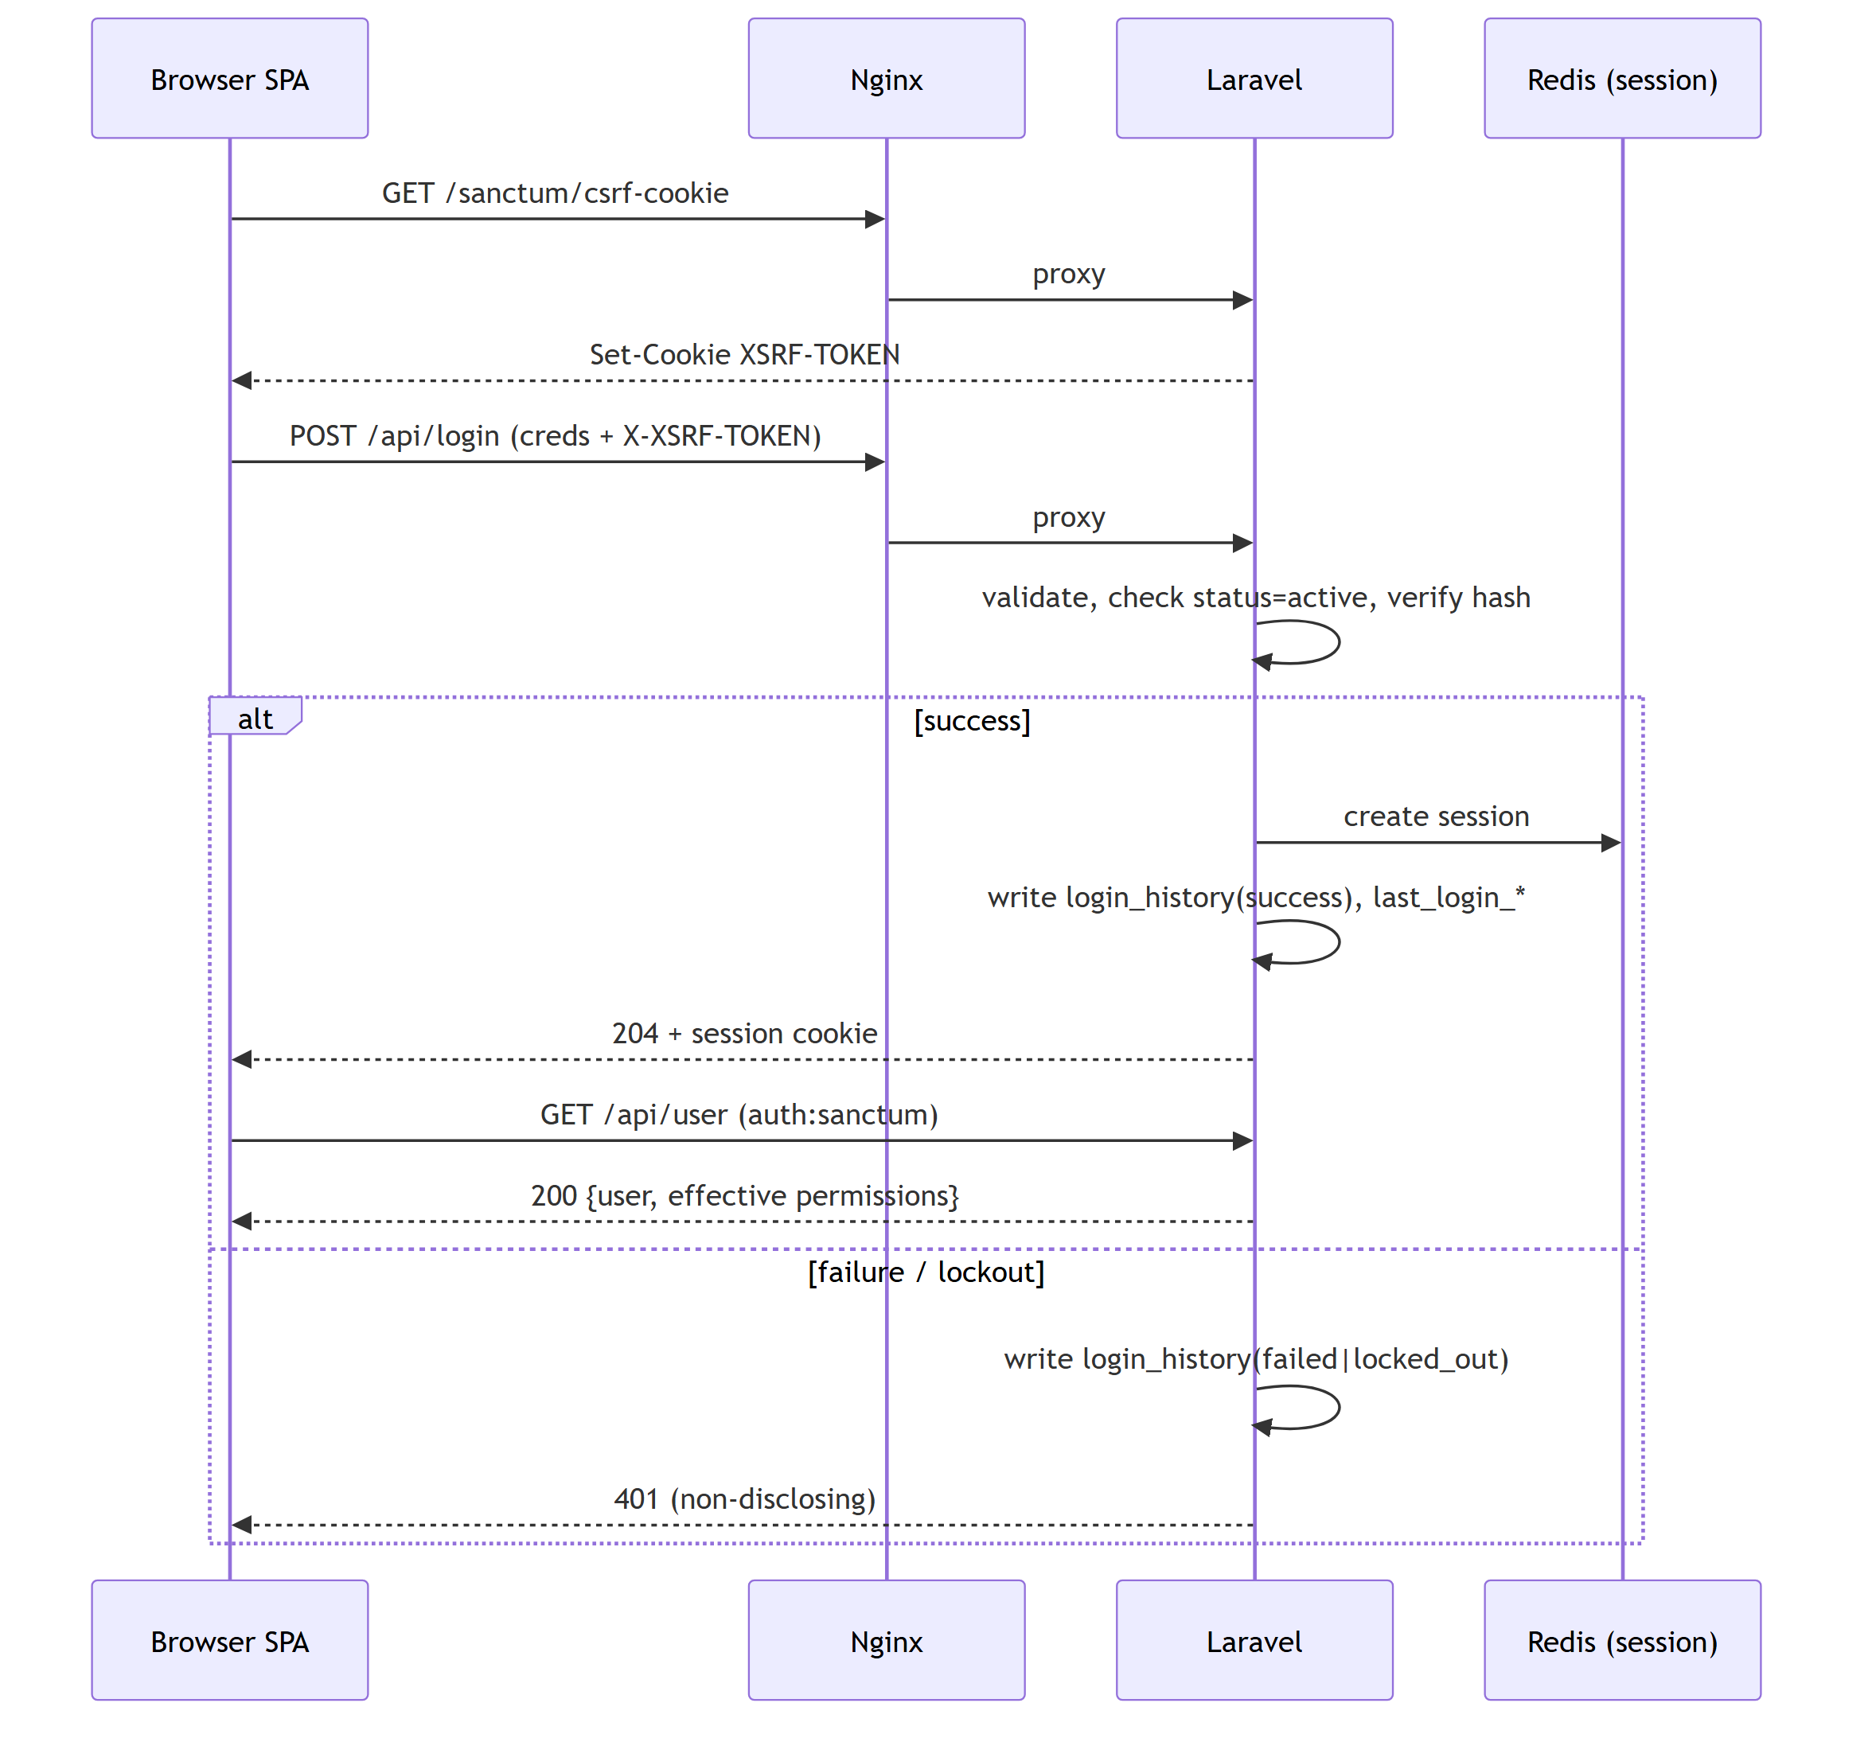
Figure …. Authentication (Sanctum SPA login).

35.2 Ticket creation + async AI analysis
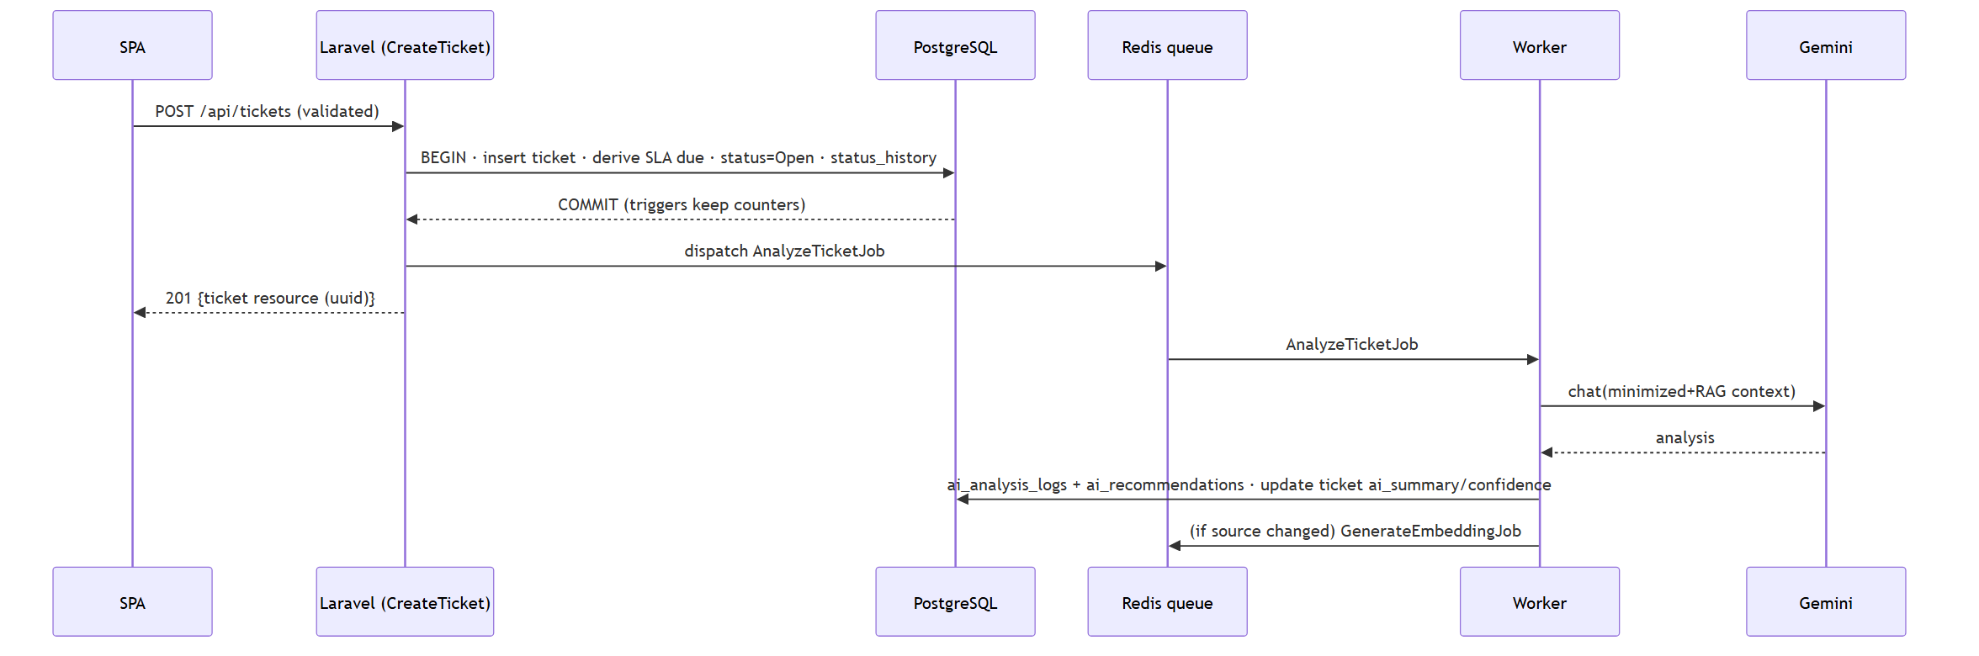
Figure …. Ticket creation + async AI analysis.

35.3 RAG assistant query
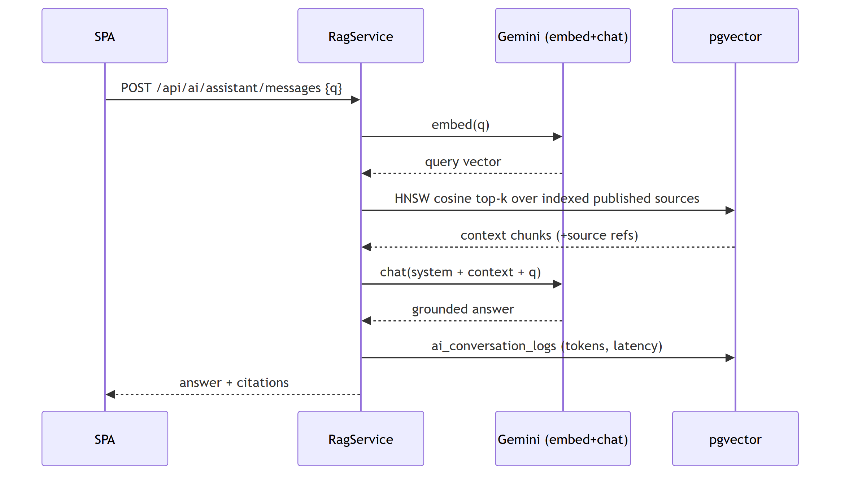
Figure …. RAG assistant query.

35.4 QR scan verification
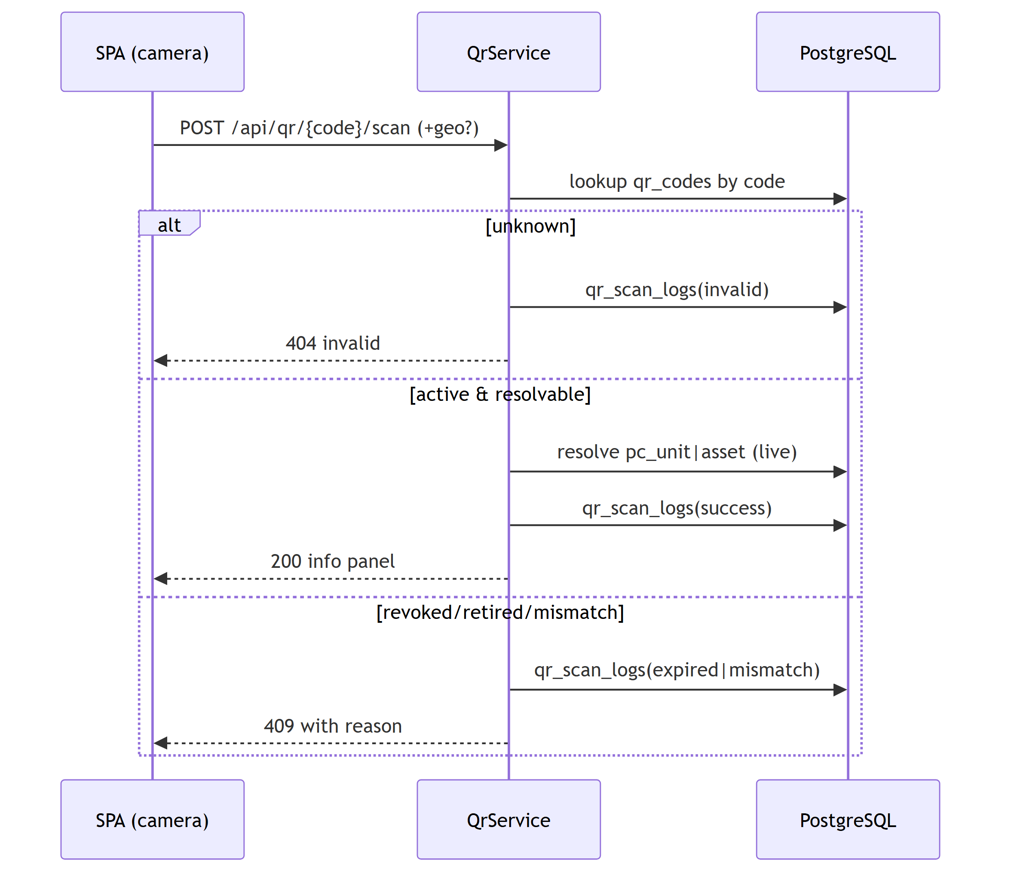
Figure …. QR scan verification.

35.5 Authorization check (permission gate)
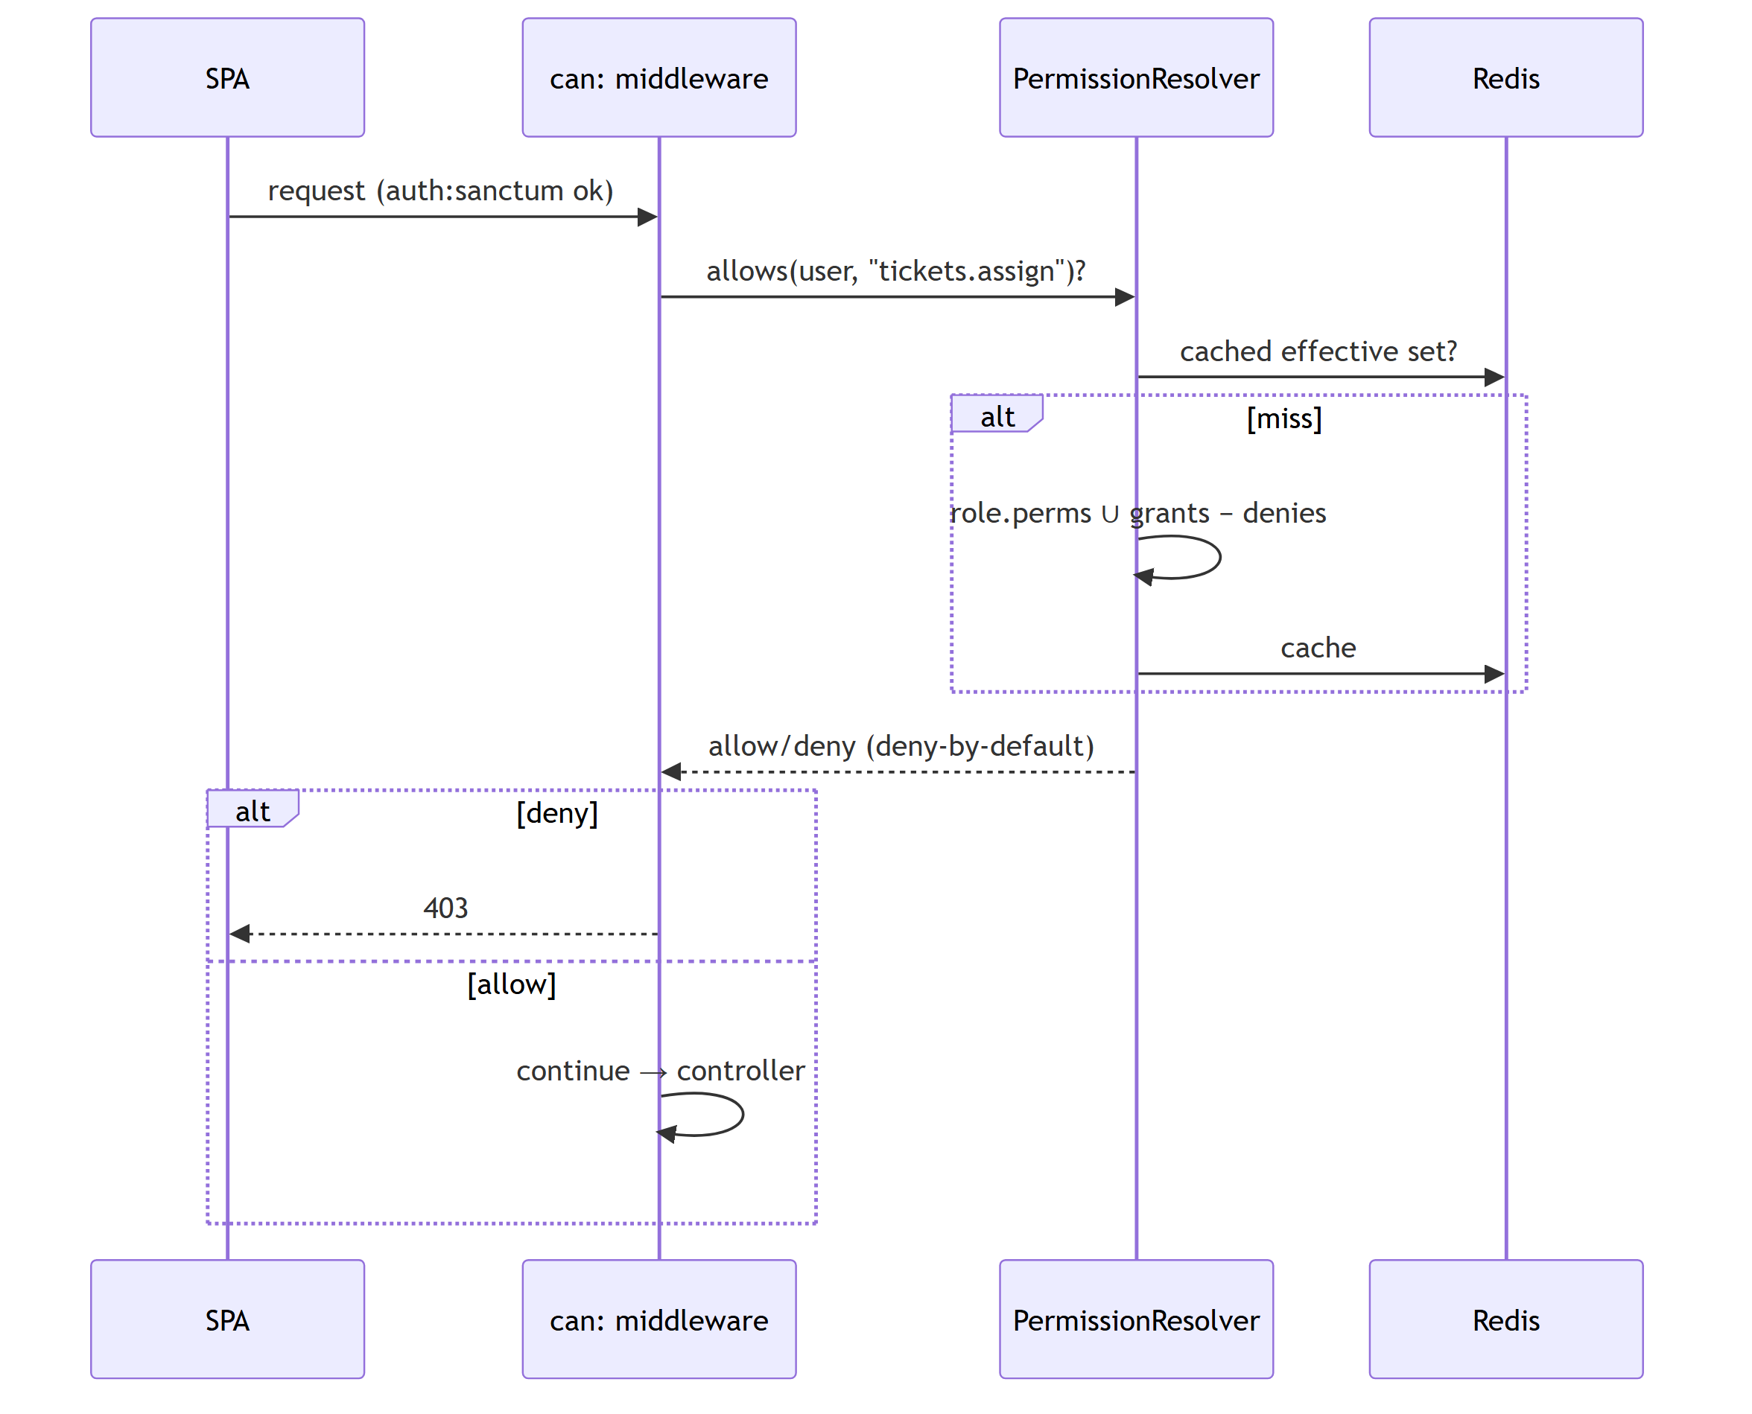
Figure …. Authorization check (permission gate).

35.6 Registration request & approval
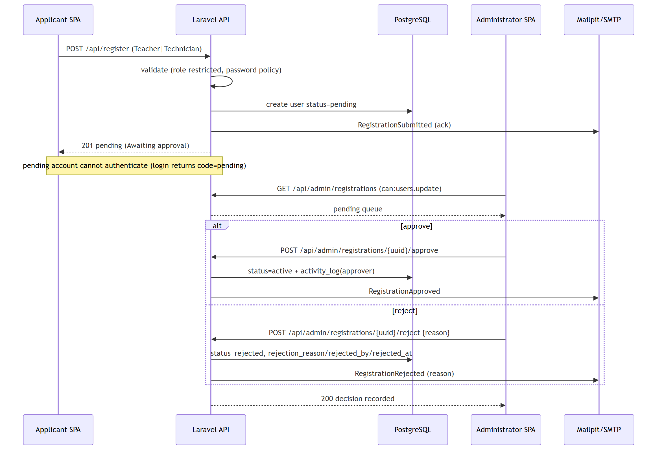
Figure …. Registration request & approval.

35.7 Real-time floor-plan update (P4)
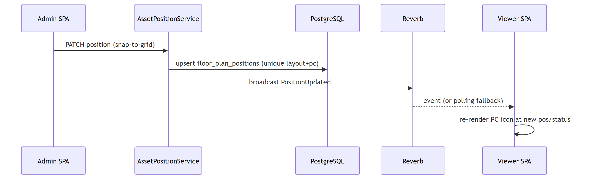
Figure …. Real-time floor-plan update (P4).

36. Component Diagrams

36.1 System components
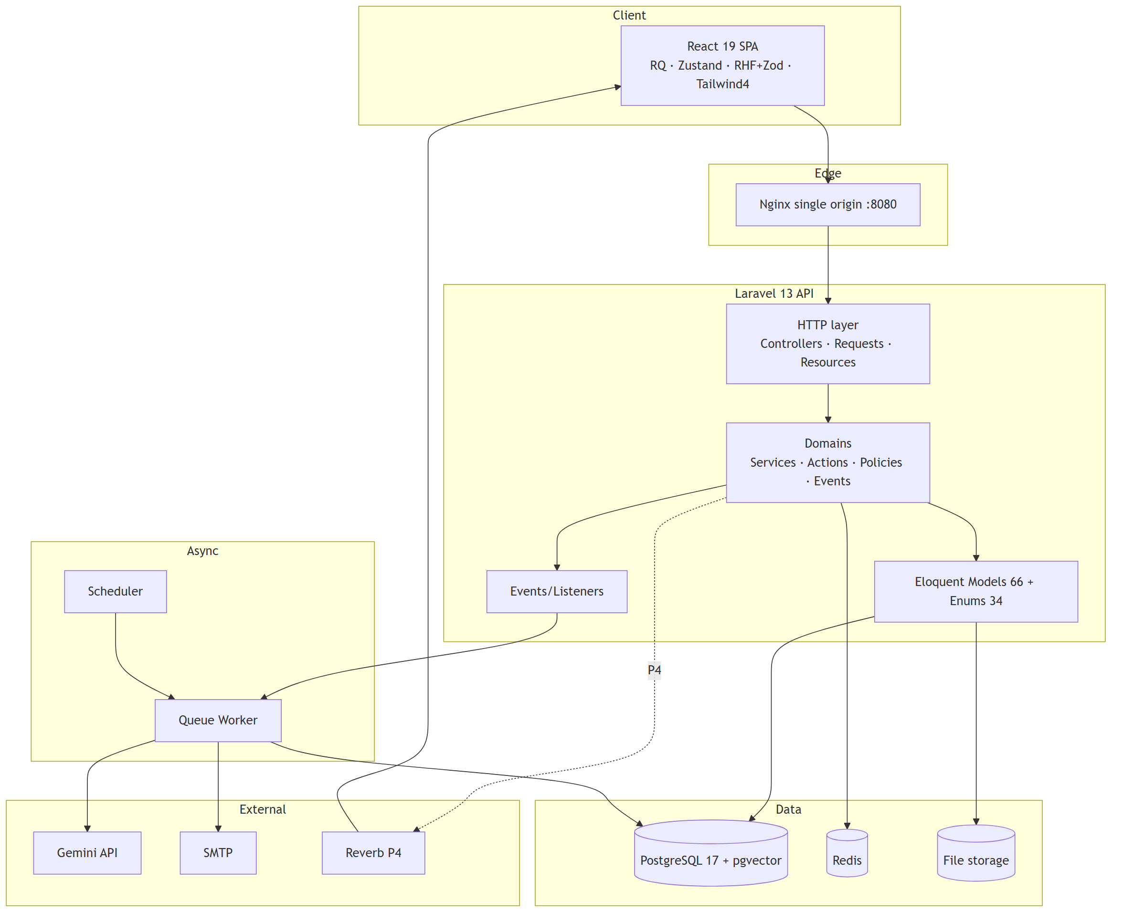
Figure …. System components.

36.2 Backend domain components
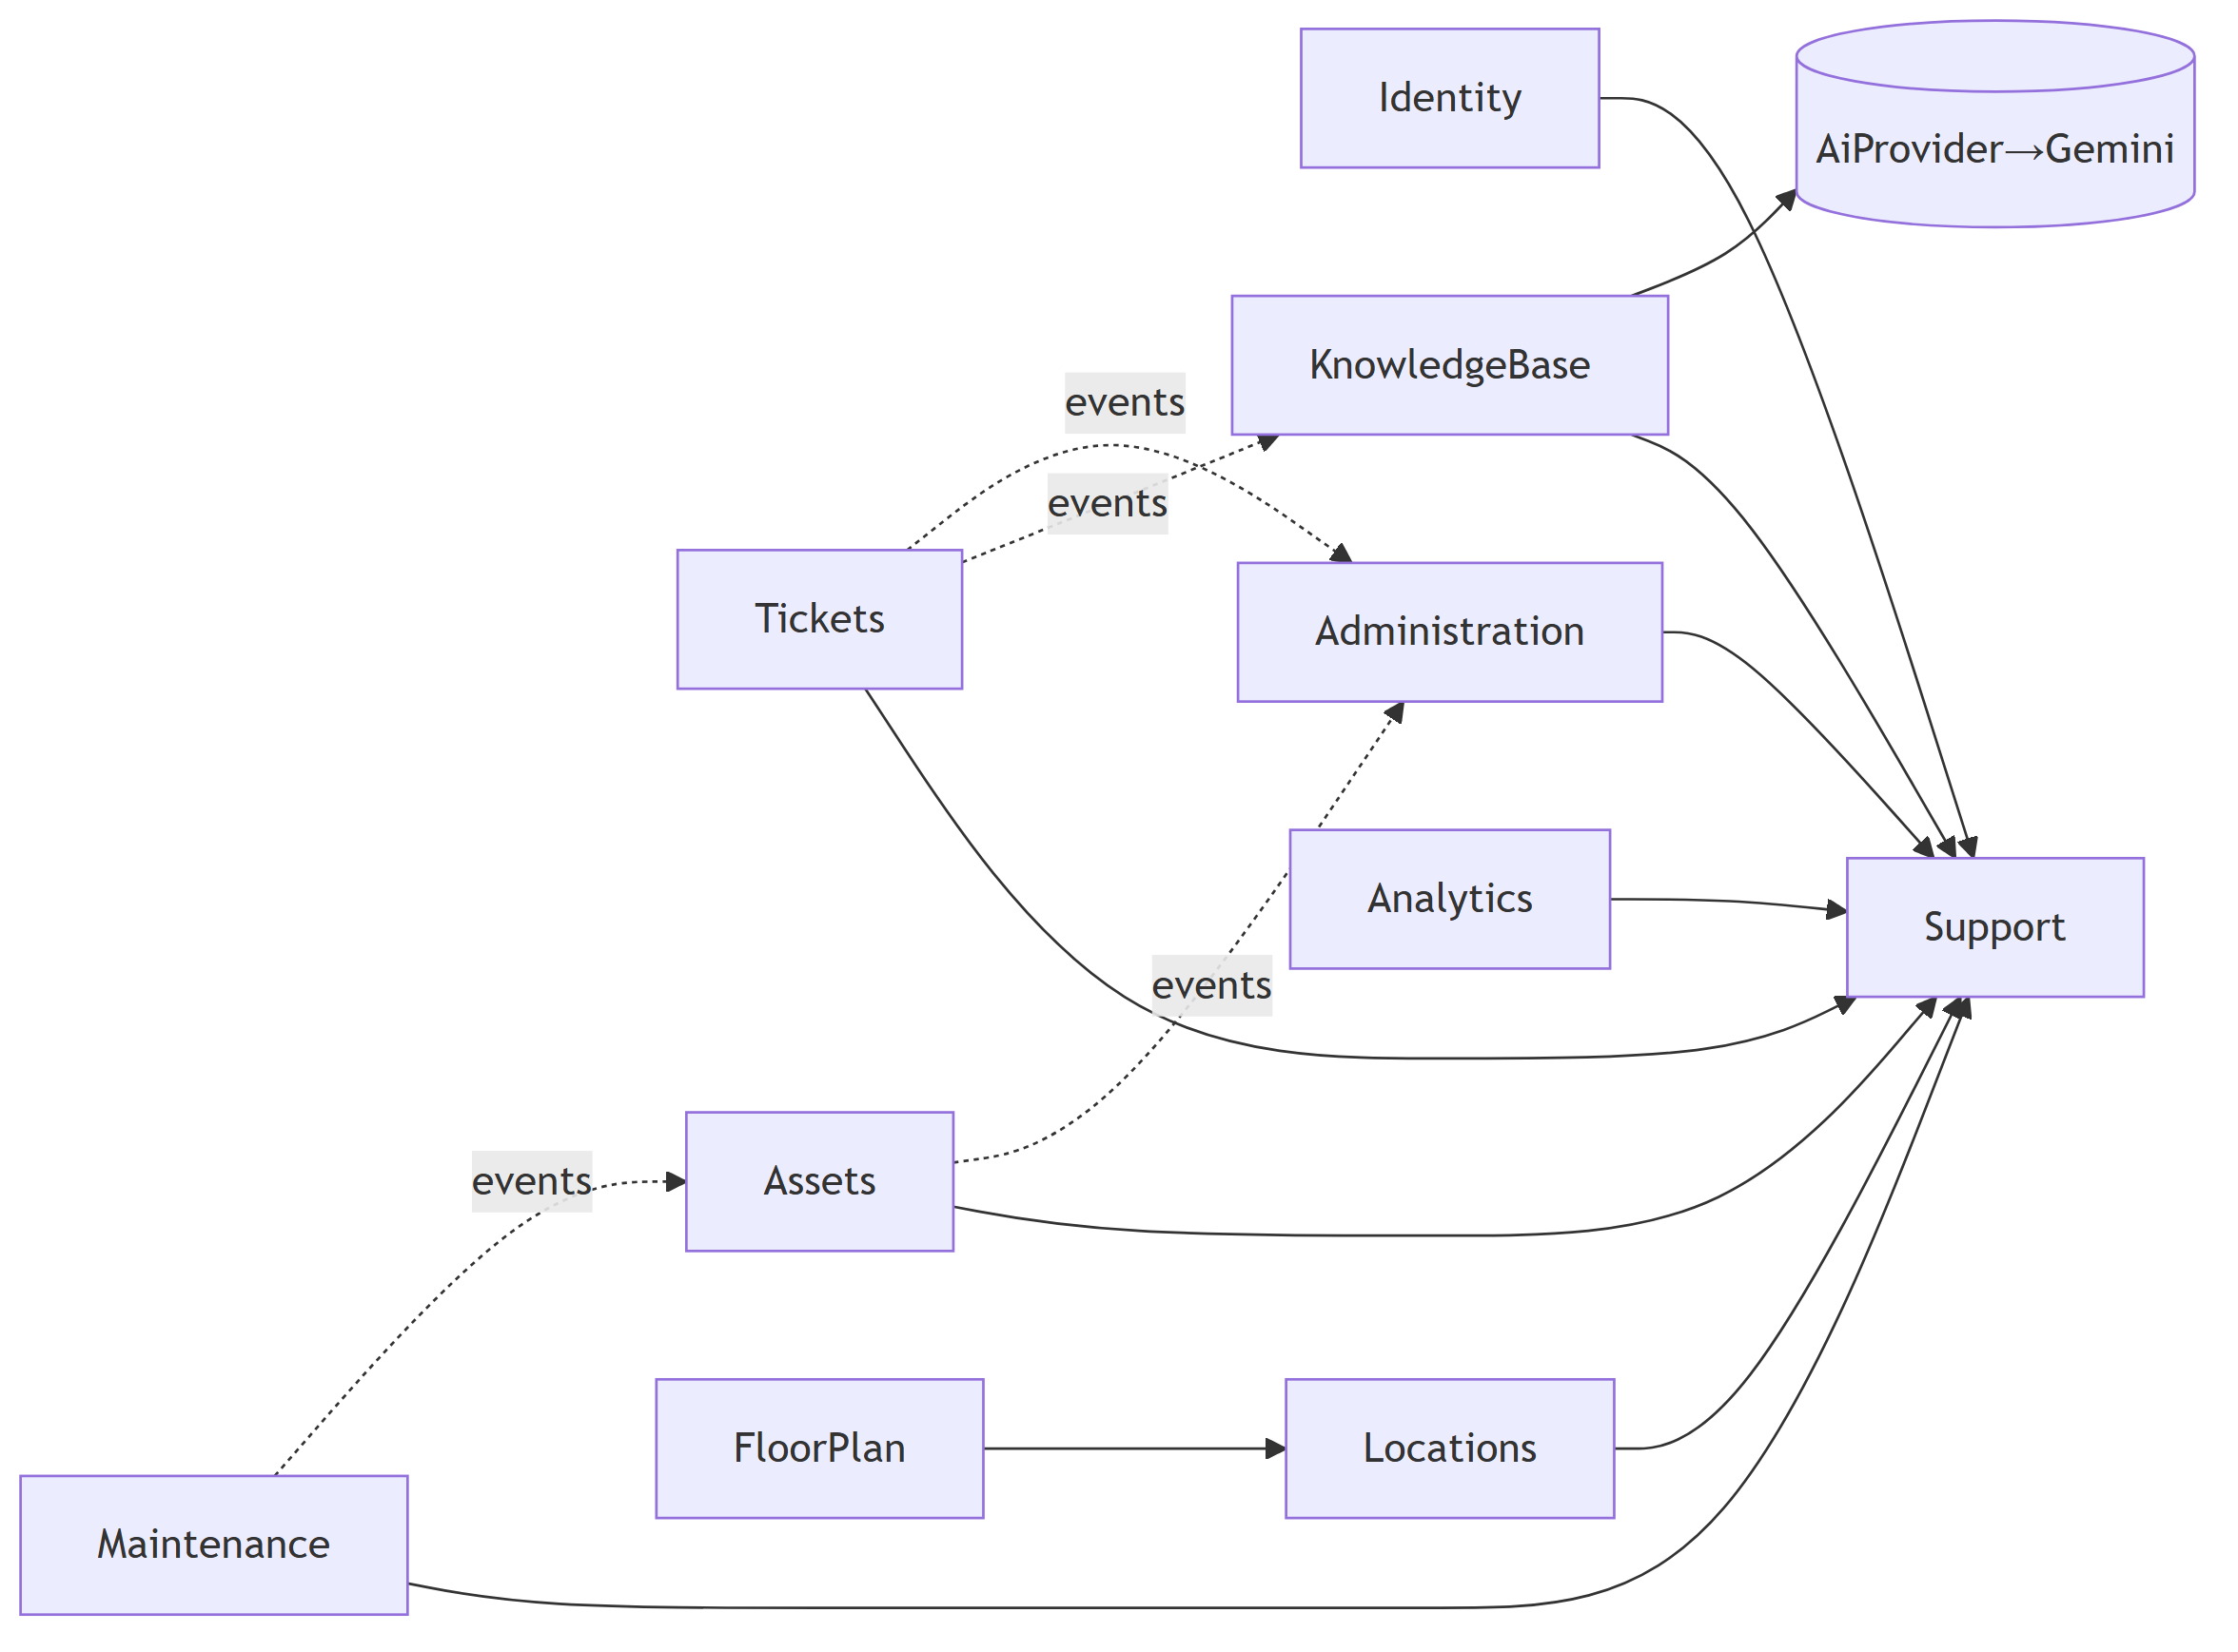
Figure …. Backend domain components.

37. Deployment Diagrams

37.1 Container topology (dev)
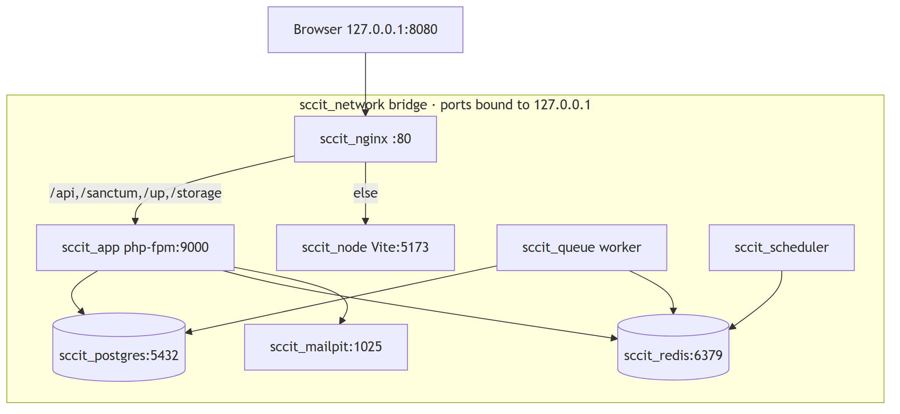
Figure …. Container topology (dev).

37.2 Production shape (target)
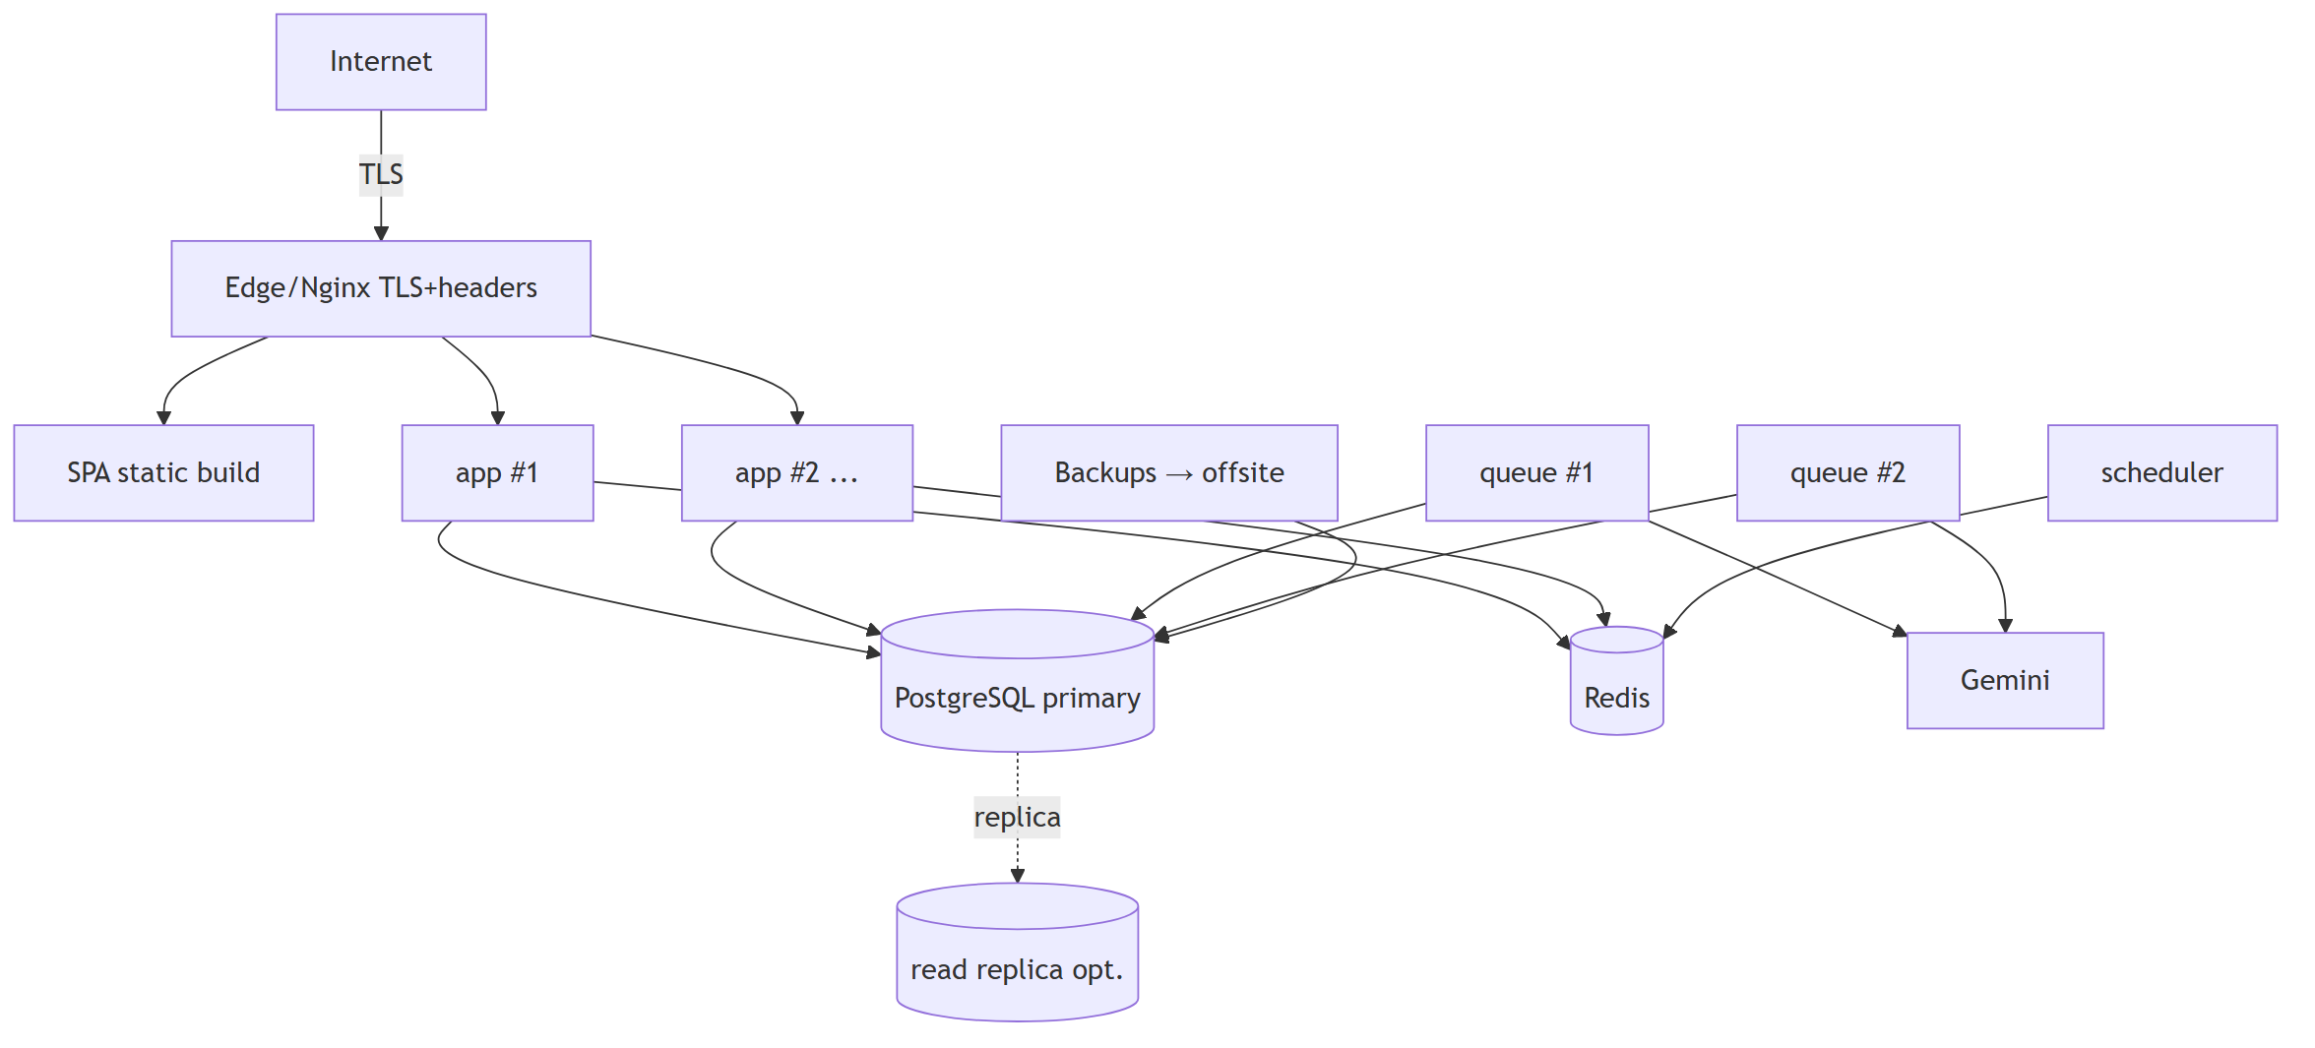
Figure …. Production shape (target).

38. Future Extension Points
Reserved so features add without major refactoring (SRS §34). Each is a seam, not scope.
Table …. Future Extension Points
ID | Extension | Seam already present
EXT-01 | Interactive Floor Plan build (P4) | Locations/layout/position tables; Reverb env placeholders; floor-plan slice.
EXT-02 | Predictive maintenance at scale | ai_predictions, ai_failure_patterns, ai_learning_events; toggle in ai_system_settings.
EXT-03 | Saved/scheduled reports + materialized views | ReportingService boundary; add report_definitions/scheduled_reports.
EXT-04 | Multi-role users | RBAC engine reads a permission set — add role_user pivot + resolver change.
EXT-05 | MFA (TOTP) | Sanctum auth flow; add users MFA columns + enrollment.
EXT-06 | Programmatic API tokens | personal_access_tokens already present.
EXT-07 | Network topology / heat maps | pc_units.ip/mac; future network_interfaces/device_connections; optional PostGIS.
EXT-08 | Log partitioning | Append-only logs BRIN-indexed, partition-key aligned.
EXT-09 | Additional locales | Externalized strings (NFR-I18N-001); add locale resources.
EXT-10 | Provider swap / new AI models | AiProvider interface + ai_models registry (data-driven).
EXT-11 | Multi-tenancy | Would require tenancy/RLS re-architecture — flagged, not seamed.

39. Design → Requirement Traceability
Table …. Design → Requirement Traceability
Design area (§) | Realizes (SRS)
Auth (§10) | FR-AUTH-001..011, NFR-SEC-003/009
Authorization + RBAC (§11–12) | FR-USER-001..010, NFR-SEC-002/017, §8 roles, BR-01/02
PostgreSQL (§8, §13) | DR-001..014, NFR-AVL-007, NFR-PERF-007
Laravel/domains (§6, §14–16) | NFR-MTN-003, all FR-* domains
React (§7, §15) | NFR-USB-, NFR-ACC-, NFR-PERF-003/004, NFR-CMP-005
API (§17) | EIF-API-001..004, NFR-SEC-001
Data flow/async (§18) | FR-AI-021, FR-MNT-007, FR-TKT-017, NFR-PERF-009, NFR-AVL-006
Error handling (§19) | NFR-SEC, NFR-AVL-005
Logging/Audit (§20–21) | NFR-OBS-, FR-AUD-, NFR-SEC-010/017, BO-06
AI + RAG (§22–23) | FR-AI-* , DR-010, NFR-PERF-006, NFR-SEC-012/013
QR (§24) | FR-QR-*, BR-09
Floor Plan (§25) | FR-FP-*, NFR-ACC-008
Notifications (§26) | FR-NOT-*
Dashboard/Reporting (§27–28) | FR-DSH-, FR-RPT-, NFR-PERF-008
Security (§29) | SRS §12 (NFR-SEC-*)
Performance/Scalability (§30–31) | SRS §13–§14
Maintainability/Standards (§32–33) | NFR-MTN-*, NFR-CMP-004
Settings integration (§6.5, §7.4, §26) | FR-CFG-*, BO-08

40. Design Decision Register
Table …. Design Decision Register
ID | Decision | Rationale | Trace
DD-01 | Modular monolith (not microservices). | Single-tenant, one team; correctness/maintainability; scale via stateless replicas. | CON-08, NFR-SCAL-003
DD-02 | Domain-oriented, no repositories (Eloquent + Services + Actions). | Established seam; less ceremony; add repo only if justified. | NFR-MTN-003
DD-03 | Models flat in App\Models; enums in App\Enums. | Factory discovery + maintainability across 66 models (as implemented). | NFR-MTN-004
DD-04 | Sanctum SPA cookie auth, single-origin, no CORS. | First-party cookies, no tokens in JS, simpler + safer. | FR-AUTH-001, NFR-SEC-003
DD-05 | Effective permission = role ∪ grants − denies; deny-by-default; Redis-cached. | Flexible RBAC with per-user overrides; performance. | FR-USER-004/005, NFR-SEC-002
DD-06 | uuid route keys via HasUuidRouteKey. | Kill IDOR/enumeration. | NFR-SEC-001
DD-07 | Enums = PHP enum + DB CHECK; lookups = tables. | Migration-friendly + single source of truth. | DR-004
DD-08 | Invariants enforced at DB (FK/CHECK/partial-unique/trigger). | Last line of defense against app bugs. | DR-002/005/012, NFR-AVL-007
DD-09 | Counter caches via DB triggers. | Never drift; O(1) list reads. | DR-009
DD-10 | Async via Redis queues; one image / three roles (app/queue/scheduler). | Non-blocking UX; graceful degradation; simple ops. | FR-AI-021, NFR-PERF-009
DD-11 | AI behind AiProvider interface; models data-driven (ai_models). | Provider independence; swap without code. | FR-AI-015
DD-12 | RAG store decoupled (ai_embedding_sources + ai_embeddings HNSW). | Independent scaling; staleness tracking. | FR-AI-006/007, NFR-SCAL-005
DD-13 | React Query (server state) + Zustand (UI) + RHF/Zod (forms). | Clear state boundaries; cache correctness. | NFR-USB, NFR-PERF-004
DD-14 | Design via DESIGN.md OKLCH role tokens through Tailwind 4. | Dual-theme AA; one-token re-brand. | FR-CFG-005, NFR-ACC, BO-08
DD-15 | API Resources; uuid-only; consistent envelope + pagination. | No id leakage; predictable client contract. | EIF-API, NFR-SEC-001
DD-16 | Reverb for real-time (P4) with polling fallback. | Live floor plan/notifications; degrade gracefully. | FR-FP-007, FR-NOT-007
DD-17 | Registration is request-and-approve (public request → pending → Administrator approve/reject), Teacher/Technician only. | Resolves OI-02; lets applicants self-serve onboarding while a human gate controls access and Administrators are never self-registerable. | FR-AUTH-013..016, BR-01a
DD-18 | Dedicated rejected UserStatus plus rejection_reason/rejected_by/rejected_at (approval actor/time in activity_logs). | Cleanest long-term lifecycle model; retains rejected requests for audit without overloading inactive. Additive migration alters the users_status_check CHECK (the PHP-enum-mirrored CHECK design was chosen to allow this). | FR-AUTH-014, DR-004/015
DD-19 | Single EnsureAccountIsActive middleware is the one source of truth for account-status enforcement; login verifies credentials before disclosing non-active status. | No duplicated status checks in controllers; balances FR-AUTH-004’s non-disclosure with the applicant’s need to learn their outcome. | FR-AUTH-004/016
DD-20 | Account lockout + endpoint throttling via Laravel’s Redis-backed RateLimiter (email+IP), not schema columns. | Matches the stateless-in-Redis design; no schema change; standard framework pattern; login_history still records locked_out. | FR-AUTH-006, NFR-SEC-009
DD-21 | Directory search/filter/sort is a dedicated UserDirectoryQuery service with a fixed sort-column allow-list; the same builder backs the exporter. | All directory work happens in the database (server-side pagination); a client-supplied sort can never reach raw SQL (injection-safe); export mirrors the current view for free. | FR-USER-013/015, NFR-PERF, NFR-SEC-001
DD-22 | Lockout state and last-activity are derived, not stored: AccountLockService reconstructs the login:{email}\|{ip} RateLimiter keys from recent login_history (shared with AuthService via LoginThrottle) to read/clear them; last-activity is MAX(activity_logs). | Keeps Phase 2.2’s lockout design intact (no new columns); gives Administrators a real “unlock” and an accurate “is locked” read without a persisted flag to keep in sync. | FR-USER-016, FR-AUTH-006
DD-23 | Account-safety invariants live in UserGuard, enforced by both UserPolicy (403) and the lifecycle Actions (defense-in-depth): no self suspend/deactivate/archive/role-change/permission-removal, and never demote/suspend/archive the last active Administrator. | Prevents privilege escalation and self-lockout; a single source of truth for the “last admin” query used by policy and actions alike. | FR-USER-018, NFR-SEC
DD-24 | A new additive EnsurePasswordIsCurrent middleware gates feature routes behind the force_password_reset flag (with /user, /password, /logout exempt); the flag clears automatically on any password change. | Server-side enforcement of “force reset” without touching the 2.2 login flow; the SPA routes the user to reset. | FR-USER-016
DD-25 | Export uses maatwebsite/excel (PhpSpreadsheet) for true .xlsx plus native streamed CSV, driven by an allow-listed column set. | Meets the CSV and Excel requirement with one export definition; no sensitive column is exportable. | FR-USER-015
DD-26 | Field reconciliation: username→search over email + employee_number (email remains the login identity); organization→deployment branding (single-tenant); department/laboratory/building deferred to future Employee/Organization Management; only force_password_reset/password_changed_at/registration_source added. | Honours the specified single-tenant, email-login, one-role-per-user baseline; keeps the module extensible without pre-empting future org modeling. | FR-USER-002, DR-016, CON-08
DD-27 | The cascade stamp is the receipt. Archiving a building/floor writes one deleted_at timestamp across the whole subtree; restore reverses exactly the rows carrying that stamp. Because deleted_at is second-precision, LocationArchiver advances the stamp until no descendant already holds it. | The ON DELETE CASCADE foreign keys never fire for a soft delete (it is an UPDATE), so children must be stamped explicitly or they stay “live” under an invisible parent. Using the existing column as the receipt keeps the baselined schema untouched, and the uniqueness step makes restore unambiguous — a room archived separately last week is not resurrected by restoring its building. | FR-LOC-004, DR-018
DD-28 | New locations permission module (view/create/update/delete), seeded to Administrators only — including view. A coarser alternative (reusing system.settings.manage) was rejected because it could not express per-action location authorization and would couple the estate to unrelated settings. (Superseded an earlier draft that seeded locations.view to all three roles; the Client scoped the module to Administrators, and FR-LOC-011 + DD-31 replace that read path.) | Managing the estate is site administration, not day-to-day work: a Technician or Teacher never needs the directory, tree, metrics or detail pages, so the least-privilege position is to grant them nothing. Per-user overrides (FR-USER-004) still let an Administrator deputize a specific account without widening a role. | FR-LOC-011, §8.4 matrix
DD-31 | The location field is a separate, narrow lookup, not a slice of the module. /api/lookups/{rooms,buildings,floors} is authorized by a selectLocation ability that the consuming workflow’s permission grants (tickets.create, maintenance.view, assets.transfer, …) — never by locations.* — returns labels only, and is served from a shared frontend component (components/LocationSelect.tsx + services/lookups.ts) that is deliberately outside features/locations/. | A form still has to let someone name a place even though the module is closed to them. Deriving the lookup’s authorization from the workflow keeps one rule (“you may name a location if you may do the thing that needs one”) and makes the lookup unable to become a back door: it exposes no operational data, and no consuming feature can reach the admin slice through it. Putting it under /lookups rather than /locations makes the boundary legible in the route list itself. | FR-LOC-005/011
DD-29 | Permission split for the archive refusal: the Policy answers permission only (403); the in-use invariant lives in the Action and answers 422 + blocker report. The same guard is exposed read-only on the detail endpoints (meta.in_use) so the UI can warn before the attempt. | “You may not archive locations” and “this room still holds equipment” are different answers and must not collapse into one status code; the 422 carries the payload the UI needs to offer reassignment. Defense in depth is preserved — the Action is the single write path and always consults the guard. | FR-LOC-004/009
DD-30 | Dashboards: role picks the layout, permissions pick the content, assembled server-side behind one endpoint; distributions render as labelled proportional rows whose markup is the data table, in a single hue, with no charting dependency. | One endpoint cannot leak what it never assembles, and the client never has to filter privileged figures. On the visual side: comparing magnitude is the job, and statuses/priorities have no inherent order, so shading rows by size would double-encode length as colour; a table-as-chart means the accessible reading and the visual reading are the same object (FR-DSH-007) and adds no bundle weight to the aging hardware the product targets. | FR-DSH-001/005/007/008, DR-019

Appendix A — Architecture Review & Consistency Verification
Per the required post-generation process: a complete architecture review verifying consistency with the SRS and the implemented database, and resolving objective issues without changing specified requirements.

A.1 Method & sources
Reviewed this SDD against: the SRS v1.0 (all FR/NFR/DR/BR/EIF/OI IDs); the implemented database (database_design_v2.dbml, create_advanced_db_objects migration — triggers/FTS/HNSW/BRIN/partial indexes read directly; 66 models; 34 enums; 9 seeders); and the current repository (composer.json, package.json, compose.yaml, docker/php/Dockerfile, docker/nginx/default.conf, bootstrap/app.php, routes/api.php, frontend/src/services/*, vite.config.ts, Ticket.php, HasUuidRouteKey, HasValues). Where the SRS listed codebase-memory-mcp/Graphify/Claude-Mem as sources, the authoritative primary artifacts (the files themselves) were read directly.

A.2 SRS consistency — confirmed
Every SRS module and requirement group has a corresponding design element with an explicit trace (§39). Phasing (P2/P3/P4/Future) is preserved. No design element contradicts a specified requirement. [RES-07] OI-02 resolved (SRS v1.0): the Client adopted the registration-request + Administrator-approval workflow (Teacher/Technician only); this SDD realizes it in §10.3, DD-17..20, and the Identity domain (§14.1). The remaining §33 open items (OI-01, OI-03..07) are still honored as-is and reflected as extension points where relevant (EXT-04/05, RES-04).

A.3 Database consistency — confirmed against implementation
Design claims were checked against the actual migration, not just the DBML: - Counter-cache triggers exist for votes, attachments, and soft-delete-aware comments — §8.4/§21 match. - audit_logs_immutable trigger exists — §21/NFR-SEC-010 match. - Partial-unique indexes exist for one-active-layout, one-active-assignment, one-active-installation-per-asset, single-default-status; notifications_unread partial index exists — §8.2/§30 match. - FTS generated search_vector + GIN on tickets and ai_knowledge_articles; HNSW cosine on ai_embeddings(768); BRIN on audit/activity/qr_scan — §8.3/§22–23 match. - Model conventions (HasUuidRouteKey, SoftDeletes, casts(), typed relations) match Ticket.php. - Auth design matches bootstrap/app.php (statefulApi) and services/api.ts (withXSRFToken, /sanctum/csrf-cookie) and Nginx (no CORS).

A.4 Architectural inconsistencies found & resolved (no requirement change)
- [RES-01] Location CRUD placement. FloorPlan/README.md bundles Building/Floor services, but FR-LOC is P2 and the floor plan is P4. Resolved: extract Building/Floor/Room CRUD into a Locations domain (P2); FloorPlan (P4) keeps spatial/layout services built on Locations (§14.1).
- [RES-02] Missing identity/administration domains. SRS defines Auth/Users/Settings/Notifications/Audit modules, but only 6 domain seams exist. Resolved: add Identity and Administration domains in P2 (the modular structure explicitly supports adding modules) — documented, not a requirement change.
- [RES-03] Session store. DBML has a sessions table while compose.yaml comments Redis for sessions. Resolved: session driver is configurable; production uses Redis for statelessness (NFR-SCAL-003); the sessions table remains the database-driver fallback. No conflict.
- [RES-04] QR expired semantics. Mirrors SRS [OI-04] — no expiry column exists. Resolved (design): expired is computed from QR/target status (§24); a date-based expiry remains an open client decision.
- [RES-05] Body-size limits. Nginx allows 50 MB but SRS default attachment cap is 10 MB. Resolved: Nginx is the outer transport limit; the app enforces the configurable business limit (FR-TKT-008). Consistent, documented.
- [RES-06] report_definitions/scheduled_reports absent. SRS marks saved/scheduled reports Future. Resolved: P2 reporting is on-demand + export; the tables are an extension point (EXT-03), not designed into P2.

A.5 Duplication check
The SDD references SRS requirements rather than restating them; it references database_design_v2.dbml rather than re-listing the schema. The two audit trails (audit_logs vs activity_logs) are a documented, non-overlapping split (§21). No section duplicates SRS content.

A.6 Residual items
None blocking. The design is internally consistent, consistent with the SRS, and consistent with the implemented database. The only forward dependencies are the SRS §33 open decisions (unchanged) and the P2 creation of the Identity/Locations/Administration domain folders (RES-01/02), which are ordinary build tasks, not design gaps.

End of Software Design Description v1.0 — Version 1.0 baseline — Waiting for Client Approval.

